## 

# TABLE OF CONTENTS

**TABLE OF CONTENTS** **2**

**INTRODUCTION** **5**

**PROCESS DESCRIPTION** **6**

**DESIGNING ALTERNATIVES** **9**

OVERVIEW 9

RESPONSE TO FEEDBACK 9

SYSTEM CONCEPT STATEMENT 9

SUMMARY OF FEEDBACK FROM EVALUATIONS IN REPORT 1 AND 2 11

DESIGN GUIDELINES 11

GUIDING DESIGN THEORY 15

SEVEN INTERACTION DESIGN FOUNDATION 15

GESTALT’S THEORY 17

FITTS’S LAW AND HICK’S LAW 18

PROTOTYPE IMPROVEMENTS AND JUSTIFICATION 19

SYSTEM REQUIREMENTS 23

SUMMARY 25

**PROTOTYPE** **26**

OVERVIEW 26

ANNOTATED SCREENSHOTS 27

DESIGN TASK FLOW 34

RATIONALE AND DEVELOPMENT OF DESIGN 35

REWARDS PAGE 36

GENERAL 37

SUMMARY 37

**EVALUATION** **38**

OVERVIEW 39

PLURALISTIC EVALUATION 39

HEURISTIC EVALUATION 41

USER EVALUATIONS 43

Rationale for chosen metrics / methodologies 43

(Quantitative) Time Taken and Task Completion and Note Taking 43

(Qualitative) TAM and SUS: 44

Evaluation Protocol 44

Results 45

Task Time 45

Task Completion Score 45

TAM Questionnaire 46

SUS Questionnaire 47

SUMMARY 48

**ESTABLISHING REQUIREMENTS** **49**

OVERVIEW 50

ANALYSIS 50

USER NEEDS 51

POSSIBLE FUTURE DIRECTION/IMPROVEMENT update 53

SUMMARY 54

**CONCLUSION** **54**

**REFERENCES** **55**

**APPENDIX** **57**

APPENDIX 1: EVALUATION PROTOCOL 58

APPENDIX 2: RAW DATA 60

APPENDIX 3: RESPONSE TO FEEDBACK SUMMARY 63

APPENDIX 4: HIGH-FIDELITY SCREENSHOTS 66

APPENDIX 5: TEAM EVALUATION 75

Appendix 5.1 - Team Charter 75

Appendix 5.2 - Team Meeting Logs 77

Appendix 5.4 - Team Progress Summary 80

APPENDIX 6: CONSENT FORMS 80

# 

# INTRODUCTION

The team – Trooperz, have continued to iterate and improve upon the design for an application which aims to facilitates positive behavioural change in study efficiency through improving upon the user’s approach and perception of time management. The application – Focus, currently utilises preventative measures revolving around distraction and motivation as a means to achieve this goal of improved time management. In Report 2, Focus was developed into a medium-fidelity prototype and has since been subject to another round of intense iteration. As a result, the team have further developed upon design alternatives, the prototype, relevant evaluations and have identified additional system requirements that should be taken into consideration in future development. The team made the decision to continue to develop the high-fidelity prototype in Adobe XD – the same platform that was utilised for the medium-fidelity prototype. Indeed, the development of this prototype lead to significant challenges within the team. As the application was significantly complex, implementing the relevant functionality for each interactive element proved impossible given the time constraints. Thus, the developers reached the conclusion that the functionality should be displayed, however, the elements which shared similar functionality would all be mapped to the same page in Adobe XD. As a result, the prototype is not as complete as the team would have appreciated, however, it should be noted that this stage of the project aimed to develop a prototype – not a final version. Additionally, the team began predetermining topics to be covered in weekly meetings which allowed for this project to be a more cohesive and intuitive process. With that being said, the team has continued to closely adhere with the Interaction Design Process and have reached to stage of identifying improvements that could be made to ensure the success of Focus in the future. Indeed, this report aims to systematically document each stage of the Interaction Design Process undertaken by the team to date.

# 

# PROCESS DESCRIPTION

Trooperz have continued to closely align with the Interaction Design Process throughout the entirety this third installment of the linked project. The team has now successfully completed two cycles of the Interaction Design Process. Each of these cycles have comprised five of the six stages: establishing requirements, analysing, designing, prototyping and evaluating. It should be noted that the implementing stage has not been completed as the team have not yet developed a final product. A diagram representing the team’s progress can be seen below in Figure 1:

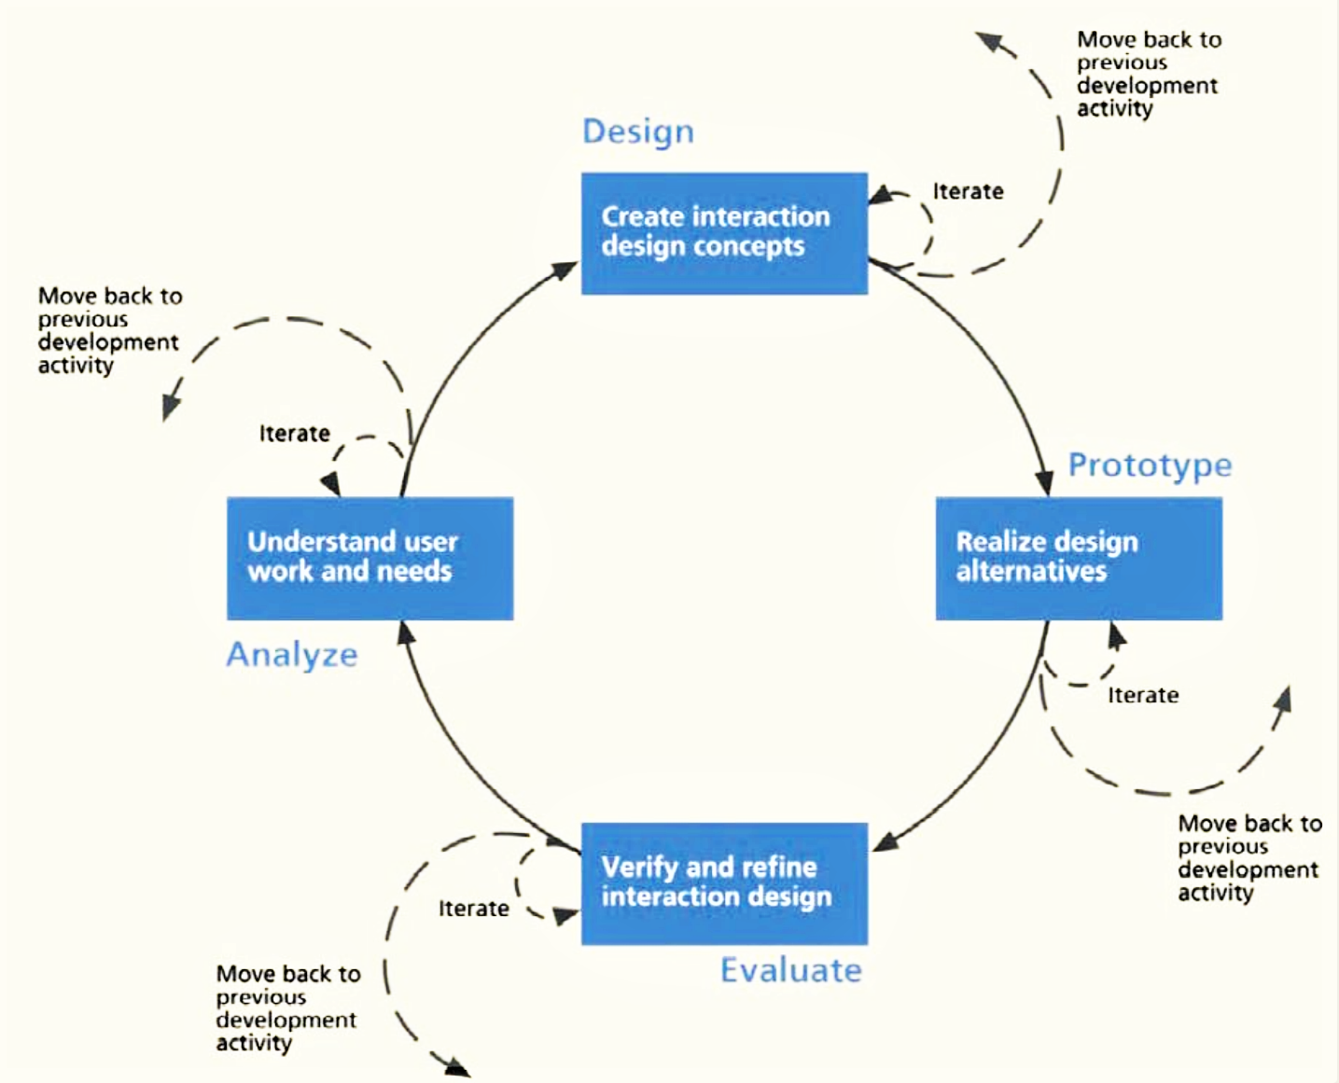

Fig. 1. Design process diagram

From an analysis and evaluation of the medium-fidelity prototype that was established in Report 2, the team was able to identify areas for future improvement (see Report 2, Establishing Further Requirements). This report predominantly comprises the ideation of design alternatives, the development and deployment of a high-fidelity prototype on end users and expert users, the evaluation of this prototype and the establishment of additional requirements that would be necessary for the future of development of the application.

The evaluation of the users’ responses to the application in its medium-fidelity state was encouraging for the team. Nevertheless, the team reached the conclusion that it was necessary to obtain a more in-depth understanding into the design decisions that were being made. Thus, the team has further analysed the raw data collected and applied relevant User Experience and Human-Computer Interaction theory amidst a reflective process as a mean to solidify and justify the design of the application.

With the rationale behind the design now better established, the team began proposing alternative designs with respect given to the requirements established in Report 2 (see Report 2, Establishing Further Requirements). With respect given to the application’s perceived strengths and weaknesses of the medium-fidelity prototype, the team extended and developed upon the system concept statement, design principles, system requirements and UX goals. As a result, the most current version of the design with a relevant purpose, functionality, rationale and goals was now systematically detailed.

This design was then compartmentalised and distributed amongst two developers. These developers were responsible for developing a high-fidelity prototype, with consideration given to the most recent design of the application. The team made the decision to continue development in Adobe XD for the high-fidelity prototype. The high-fidelity prototype aims to test aesthetic features including typography, colour schemes and iconography. However, the main purpose remains to be the identification of problem areas revolving around the functionality, usability and practicality of the system and design. Indeed, the team believed that Adobe XD was able to seamlessly and effectively facilitate the construction of an application in Report 2 and, thus, the decision to continue utilising the same software for the high-fidelity prototype was made. While creating this prototype, the team sought to effectively incorporate User Interaction Principles as a means to ensure the application was as intuitive and usable as possible. This prototyping stage of the Interaction Design Process was fundamental in solidifying an understanding of the users’ pre-determined mental models of a near final version of the application.

Indeed, It should be noted that the high-fidelity prototype is still a prototype. Thus, while the user will be given the impression that all functionality is fully implemented, the application does not cater to every possible pathway the user could navigate through. To that end, related elements on a page, such as task information and timers, will link to one ‘base page’ and, consequently, will not provide the expected textual content. Nevertheless, the high-fidelity prototype is able to provide an authentic experience which effectively reflects the team’s current perception of the final design.

After the prototype was finalised, the team then began evaluating the design on end-users. As a result, the team was able to identify any lingering issues revolving poor interface design and overall usability. As a means to gain insight into the application’s progress and alignment to the users’ expectations, all evaluators were asked to complete a Technology Assessment Model (TAM) and a System Usability Scale (SUS) upon completion of their testing period. Additionally, each evaluator was closely monitored with observations, completion status and the time taken to complete a task noted. Next, the team conducted a Pluralistic evaluation. This type of evaluation is conducted on ‘expert users’ and, consequently, is able to provide a more detailed and pertinent insight into the effectiveness of the system. Finally, the team carried out a Heuristic Evaluation on the application. This was able to systematically analyse the and identify any usability issues related to the user-interface. As a result of all the data collected, the team was able to evaluate the users’ interactions, expert feedback and interface usability, and subsequently, obtain valuable insight into the system’s effectiveness and remaining problem areas were highlighted.

With the evaluation of the high-fidelity prototype successfully completed, the team forecast Focus’ future performance as a time management application. Further, the evaluation acted as the foundations to translate these strengths and weaknesses into further requirements and potential alterations that would be required to ensure the success of the application in the future.

To date, this has been the process the team has adhered to in order to effectively design for an application which facilitates the users’ need to improve upon their time management and, subsequently, study efficiency.

# DESIGNING ALTERNATIVES

### OVERVIEW

In this step, the team further developed upon the prototype and design guidelines, informed by continued engagement with design theory and feedback obtained from evaluations conducted in Report Two. In doing this, the team was able to form a more in-depth understanding of the application’s design through identifying its purpose, principles and functionality. In this section, a more detailed justification of prototype components and improvements is provided, as well as a renewed statement of design direction.

### SYSTEM CONCEPT STATEMENT

The team aims to design and develop an engaging mobile application with minimal cognitive demands, for university students that promotes efficient time management by mitigating distraction and aiding task management through incentivisation which, in turn, enables users tostudy in a manner that is more productive within the same time constraints.

SYSTEM FUNCTIONALITY DESCRIPTION

Time management focuses on an individual’s ability to prioritise tasks and work effectively within a given time frame (Mindtools, 2017). Thus, it was necessary for the team to take these two aforementioned factors into consideration when developing an time management application. With that being said, the functionality of the application is able to be split into four main categories: task management, time management, progress and incentives.

1. TASK MANAGEMENT

As mentioned before, time management comprises an individual’s capability to work within given time constraints in addition to a capability to organise and prioritise tasks (Mindtools, 2017). Therefore, the app must track past/current/future tasks, and present useful ways in which the tasks may be viewed/sorted/prioritised. These functionalities must boost the user’s capability to complete their tasks within their given time constraints.

2. TIME MANAGEMENT

Further, the team considered the Pareto principle (also known as the 80/20 rule) when developing a time management application. To that end, the Pareto principle is a theory in which “80% of your results come from only 20% of your effort and time” (Interaction Design Foundation, 2019). Thus, the ability to harness and utilise effective study methods would prove extremely beneficial to an individual’s study efficiency. To that end, the integration of the Pomodoro timer (see Report One, Step One) used in conjunction with the Pareto principle would be able to eliminate distractions and subsequently allow for the undivided attention of the user on the task at hand (Interaction Design Foundation, 2019). Inside the app’s function, the straightforward and plain design on the timer can allow user to manage their time free from effort.

3. PROGRESS

Next, the importance of allowing users to track their progress. Progress trackers display the user’s interaction with a system through detailing the steps completed, the step they are on, and any steps that remain in order to achieve a predetermined goal (N.Babich, 2016). The application must present/frame the status of the relationship between tasks completed, tasks remaining, time spent, and time remaining in a way that is useful to the user (one in which task management and time management goals may be derived). Additionally, incentivisation goals may be achieved through the framing and presentation of this information.

4. INCENTIVES

Finally, the team has incorporated an incentive system. Indeed, incentive systems are fundamental to an effective user experience when interacting with an application. The completion of each tasks or setted timers can trigger our reward system. Users become more likely to continue interacting with a system if they are rewarded for doing so (Tubik Studio, 2017). With that in mind, the team have utilised a simple reward system which gratifies the user for interacting with the application’s functionality. Users can be goal-directed and easily measure their performance during experiencing our application.

### SUMMARY OF FEEDBACK FROM EVALUATIONS IN REPORT 1 AND 2

Low-fidelity testing demonstrated that users were, as a whole, relatively impressed with the usability of the application. Overall, users have given this experience a high rating and believe the application is easy to use and consequently, allows achieving predetermined goals to be a relatively seamless experience. Evidence of this can be found in analysing the TAM results. Indeed, all responses for the first round of TAM questions are positioned above a three, indicating a satisfaction with the application's performance (Report One, Evaluation Fig. 6.). upon analysing the TAM data, a key problem area stands to be the user's willingness to commit to regularly using the application, which was given a score of 2.9 (Report One, Appendix 4). Indeed, the team has taken this into consideration and aim to focus more on the application's incentive system as a mean to motivate the user.

Following the evaluation of the medium-fidelity prototype, many areas of improvement were identified. From these identified areas, the team was able to derive improvements that could be made in order to improve the application. Three key points of focus are listed below:

1. Consistency and Cohesiveness
2. Available features and paths of action are described clearly.
3. Available features and paths of action are prioritised appropriately.

CONSISTENCY AND COHESIVENESS

Consistency allows a user to assume functionality between content that appears to be related. In relation to Focus, users were often confused when they were presented with pop-ups to confirm deletion of tasks, but were not given the same opportunity when deleting a timer (Report 2-Appendix 2).

AVAILABLE FEATURES AND PATHS OF ACTION ARE DESCRIBED CLEARLY.

When developing a design it is imperative to consider the users ability to “to understand and use a design immediately—that is, without consciously thinking about how to do it” (Interaction Design Foundation, 2018). The medium-fidelity prototype was able to recognize that the progress component of the homepage was clickable and linked to a progress page. “I didn’t know if it was clickable” and “confusing” (Report2-Appendix 2).

AVAILABLE FEATURES AND PATHS OF ACTION ARE PRIORITISED APPROPRIATELY.

Users were hard to locate or recognise this element of functionality saying it was “too small”, “unintuitive” and “confusing” (Report2-Appendix 2). The prevalence of content on an interface is able to indicate importance (Interaction Design Foundation, 2017)

### DESIGN GUIDELINES

Design principles are a set of values agreed upon which uphold the foundations of an application. Having reflected upon the results received from testing conducted as a part of report two, and the theories and research conducted over the course of the iterative design process, we have reconsidered our guidelines. These guidelines include, but are not limited to:

1. **Accessible**: We understand that not all our users will have the same needs, wants or demands. Nevertheless, our application strives to cater for the widest range of requirements possible - including visual and hearing imparity, color sensitivity, and general dexterity. This is largely an ethical consideration, and a guideline based on our group’s values.
2. **Consistency:** Our results from the second report have shown that consistency plays a big role in the extent to which an app is viewed favourably and an app is used consistently. When an app communicates feedback or available options inconsistently, users have a harder time continuing to use the app. Our designs should be consistent within itself, and consistent with the expectations users have come to hold from engaging with systems and apps external to our own.
3. **User Centred**: The end user should always feel like they’re in the driving seat of our design system. As no two users will be the same, our app should be adaptable and responsive to each and every users’ desires. This is valuable not only to the users themselves, the app to benefits from this goal. Studies have shown that the more personalised feedback a user receives in the journey to change their own behaviour, the more effective the app is to that end.
4. **Incentivising**: We want our users to be challenged and self-motivated to continually better themselves and their time management, and we hope our application can help the user on that journey. Our scholarly research outlined in report one demonstrates the value a system of motivation can have in achieving the user’s goals and the goals of the design.
5. **Ease-of-use:** The interface architecture is to be simple and clear, the navigation should prove to be intuitive. This is important on a commonsense basis: for what reason should an app be difficult to use? For the purposes of making our app successful in its goal to change the behaviour of our users, scholarly research shows that the less data entry as user has to undertake, the more the user views the app favourably and the more the user is likely to continue longer term use.

INTERACTION PARADIGMS

An interaction paradigms is a model of HCI implementing the variety aspects of interaction. The team’s application is based on the mobile interaction. A set of interface interaction patterns that are reusable, familiar to users are displayed below:

TAB FORMAT

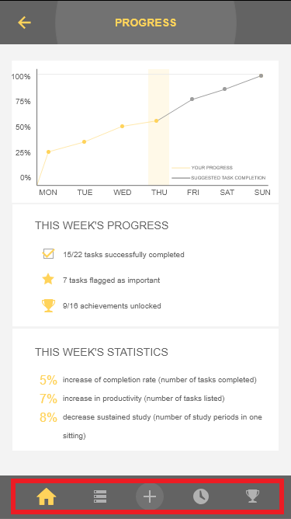

Fig. 2. Tab format applied in Focus

Features:

* Limited by screen width.
* The use of tabs can reduce cluttered interfaces, convoluted navigation, improve usability.
* Information can be displayed by horizontal or vertical Tab.
* Sometimes more content can be viewed by swiping left and right, which requires users to explore actively.
* Tab layout is preferred when functions are closely related and users need to switch between them frequently.

LIST FORMAT

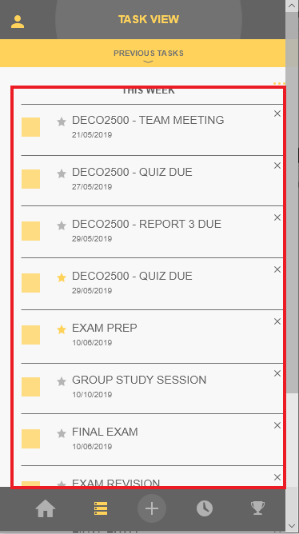

Fig. 3. List format applied in Focus

Features:

* Common layout, simple, user familiarity.
* Reading habits - the mobile phone screen is generally displayed in portrait, horizontal text display, the vertical list can contain more information.
* List length can be unlimited, by scrolling up and down to see more content.
* The vertical list is visually neat and organised was to display data with high user acceptance.

PALACE FORMAT

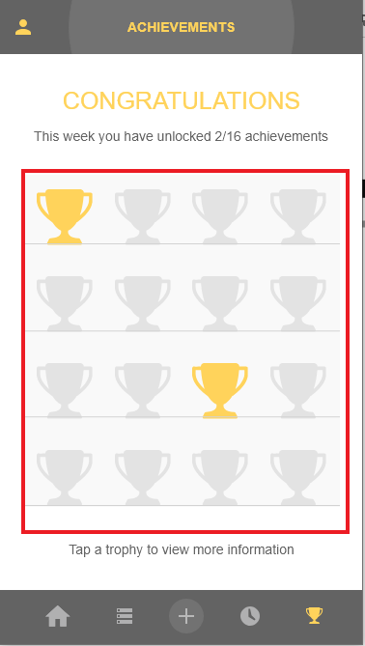

Fig. 4. Palace format applied in Focus

Features:

* Palace is a very classic design and user familiarity is high.
* Grids are an effective was to group related content systematically

POP-UP WINDOW FORMAT

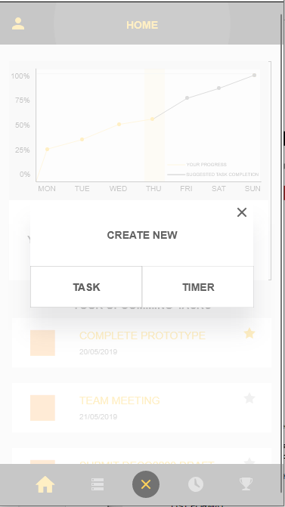

Fig. 5. Pop-up window format applied in Focus

Features:

* Pop up when needed to save screen space.
* It can be operated on the original interface without having to jump out of the interface.

INTERACTION MODES

An Interaction mode is a way of manipulating the interface to navigate through the system. Below are examples of interaction modes pertinent to the team’s application - Focus.

* **Simple:** The more gesture-dependent controls contained within an application, the fewer buttons you'll see on your screen, leaving more room for valuable content. This makes the app more content-centric and allows users to do more important things without obstacles or distractions.
* **Ease of use:** Gestures, once identified by the user, become a fundamental part of the interaction experience and can improve interaction by reducing the number of steps in the process. For example, when the user needs to delete an item on their mobile device, it can be time-consuming to click on it one at a time, and a simple shortcut is to swipe to delete.
* **Direct:** while buttons may seem like a more useful trigger, gestures have more potential and interact more directly with content.

METAPHORS

* **Verbal metaphors:** The original meaning of the word "focus" is the concentration of attention or energy on something. The team named the application “Focus” with the intention that the users will make an association between the application’s name and the need for them to persevere and concentrate on the task at hand as a means to improve study efficiency.
* **Graphic metaphor:** As the user interacts with controls in the interface, it can be seen that a stopwatch icon can stands as a graphical metaphor for "timer", a list icon can stand for "task list", a portrait icon can stand for "account", a trophy can stand for "achievement" and so on.In the task management page, the team has digitised a physical checklist as the user would be familiar with this metaphor through lived experiences

### GUIDING DESIGN THEORY

#### SEVEN INTERACTION DESIGN FOUNDATION

In relation to Focus, users were often confused when they were presented with pop-ups to confirm deletion of tasks, but were not given the same opportunity when deleting a timer. In this section, the team has outlined design theory with its respective application to the design of the high-fidelity prototype.

The team based Focus' design on the seven fundamental design principles : Discoverability, Feedback, Conceptual Model, Affordance, Signifiers, Mappings and Constraints (Norman, 2013 also from lecture 2).

#### Discoverability

A successful application should allow the user to easily predict what is possible as well as being able to seamlessly orientate themselves. As a result, our application integrated a static navigation bar at the bottom of each page which highlights the icon relating to the user's position within the application.

#### Feedback

An example of effective feedback can be seen through the popups that appear when the user is creating, altering or deleting a task/ timer. This allows the user to understand and further act upon their interactive experience with the application.

#### Conceptual Model

Further, the interaction with the application should be a consistent and continuous experience. Thus, the team has developed a consistent visual style, metaphors and interaction requirements throughout the application.

#### Affordances

Proper affordance, when implemented correctly, should promote customizability. Thus, the team has implemented an "order by" option in the task page to reflect this criterion. Any action between the system and the user should provide feedback as a means of informing the user if their interaction was successful.

#### Signifiers

Signifiers acts as a sign to indicate affordances. It tells user what to do and where to do it. In our application, our team successfully applied in input places, as we can see from (Fig. 7. Create timer interface in Focus) below, the faded text ”Your timer name” tells user what to write and where.

#### Mappings

A successful application should have strong relationship between controls and their actions followed the principles of good mapping. As a example, we use blocks in our application to separate contents and we place each set of word near rather than far from the portion of the function they describe by applying spatial contiguity.

#### Constraints

In our application, we used a larger size of ‘+’ button and in a circle will significantly reduce the time cost of clicking on this button by guiding the user actions and easing interpretation.

#### GESTALT’S THEORY

Based on the Gestalt’s Theory (from lecture 6), the team further developed the application through emphasizing the connection between the structure of functionality. Gestalt's theories, and their relevant application to the most current design, can be seen below:

##### 1. *Proximity*

When objects are close to each other, they tend to be considered as related. The team’s application locates tasks in blocks with close proximity so the user can identify that these elements are related and act upon this understanding accordingly.. This is an implementation of list format in interaction paradigm (Fig. 4. List format applied in Focus)

##### *2. Similarity*

Consistent interactions should be maintained in similar situations. With that being said, the team has utilised visually similar popups and menus throughout the system. This aims to prompt the user to identify a trend in similar functionality based on appearance. This is further maintained through the adoption of consistent colour, layout, casing and font throughout the system.

###### 3. Continuity

If elements share areas with well-defined boundaries, they tend to be grouped together. In our design, our team used blocks to combine related elements. A good use of continuity really help our team to arrangement of rows and columns, refers to the list format in interaction paradigm (Fig. 4. List format applied in Focus)

###### 4. Closure

During design the application, we always keep the relative distance in each icons or blocks same, because we know user will look for a continuous, smooth style.



Fig. 6. Main menu icons in Focus

###### 5. Symmetry

Our visual system tends to decompose complex scenes to reduce complexity, so our application is symmetric in every interface. Symmetry have implemented to the icons in the main menu (Fig.7.Main menu icons in Focus), the list format (Fig. 4. List format applied in Focus) and also the motivation page (Fig. 5. Palace format applied in Focus)

###### 6. Figure/Ground

The brain divides the visual areas into subject and background. The general idea is to include the elements of a scene that occupy all of user's attention, and the rest is the background. In our application if the pop-up windows jumps out, the background will fade simultaneously. It refers to the pop-up windows in interaction paradigm (Fig. 6. Pop-up window format applied in Focus)

###### 7. Common Fate

Common fate is concerned with moving object. It applied to the number setting interface in timer. When users want to set the number of study period duration, they need to scroll up/down the numbers, then the numbers move together appear to be a group or related.

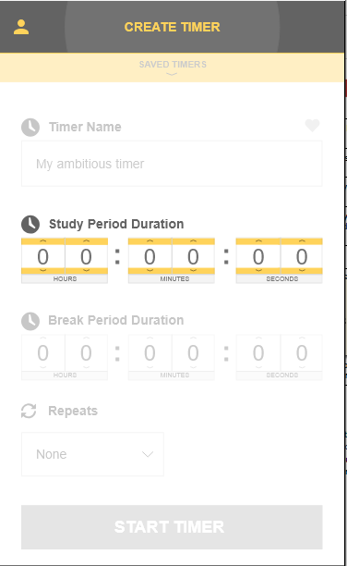

Fig. 7. Create timer interface in Focus

#### FITTS’S LAW AND HICK’S LAW

After applying Fitts' and Hick's respective laws, team has chosen to maintain the positioning of key elements of functionality. The application effectively uses appropriate size of icons and buttons that aims to maximize user efficiency. However, in order to promote a faster user interaction with minor elements of functionality such as the 'star' and 'previous tasks' buttons, the team have enlarged and recoloured these options. Indeed, these changes were also brought to the team's attention through user evaluations of the medium-fidelity prototype. (See Report 2, Establishing Further Requirements).

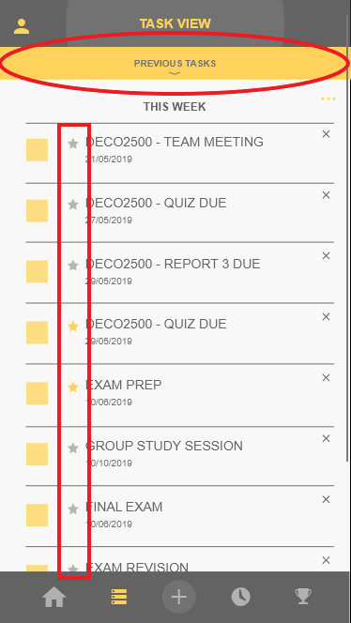

Fig. 8. Tasks interface in Focus

### PROTOTYPE IMPROVEMENTS AND JUSTIFICATION

#### *1. Task view as one section - all tasks in a singular list*

This change was based on the Hick’s law (from lecture 6), users will spend less time to decide which tasks to work on because there was two separate lists in the tasks interface. One is current tasks and one is this current week, now we minimize it one section called “THIS WEEK”.

#### *2. Task view sortable by creation date (default) or importance… three dots icons*

Proper affordance should exist to let user make their own decisions, so our team developed the function of “Order by” in the list of task interface, that allows user sort the existing tasks either by due date or importance.

#### *3. Important tasks in task view are shown as important*

By analysing the testing of medium fidelity prototype (from report 2 Evaluation part Graph. 2.), ‘Make Task 1 an important task’ proved to be the most difficult time to complete with an average completion time of approximately 34 seconds. 5 users found this particularly difficult with a completion time more than 30 seconds. Tester 5 presented a particularly long completion time as a result of failed functionality in the mobile version of the medium fidelity prototyping. This result is considered an anomaly due to the inconsistent testing environment. Discrediting this result, the average completion time for this task becomes 28 seconds, dramatically reducing the general success of this task’s completion. 11 out of 14 users attempted to complete this task from the home page task view, which did not include this functionality, thus led to frustration and extended task completion times. It is suggested that this functionality be added to the home page within the final prototype to allow easier use.

#### *4. Home screen tasks need to be interactable*

This change is implement of feedback of 7 Fundamental Principles of Design (from lecture 2). Any behavior of the user should have feedback so that the user knows what they just did and whether it was successful or not. In our high-fidelity prototype have achieved the most of function in our application.

#### *5. Protocol - tasks described as flowing hence users please don’t press anything after completion*

Some testers would like try the functions of our application due to curious, which may lengthen the testing time.

#### *6. Have all popups provide/ maintain context*

* *Large popup on top of relevant page*

This change is based on the Figure/Ground from Gestalt’s Theory (from lecture 6), when the pop-up windows comes up, the previous will be faded that aims to occupy all of users’ attention. And also this is a implement of discoverability of 7 Fundamental Principles of Design (from lecture 2), users can be more easily to locate where they are at this step.

#### *7. Have progress (on home page) relevant to usage*

* *Percentage of tasks completed (weekly)*

This is a implement of progress’s functionality.

#### *8. Have more familiar input method for timer timers*

* *Number scroll wheels*

This change is based on the common fate of Gestalt’s theory, since the number scroll wheels allows users think the numbers as a group. And this way of input is more familiar to most of the users.

#### *9. Provide more recognisable/ exclusive icons for saved timers*

* *Heart icon next to the saved timer*

By analysing the testing of medium fidelity prototype (from report 2 Evaluation part Graph. 2.), 6 of the 14 users had trouble locating the ‘saved timers’ function at the top of the screen. This meant that users weren’t efficient in Task 9 ‘Start a previously saved timer’. It was also identified that the use of the word ‘saved’ was misleading as there was no save icon present, and it is suggested that the terminology be changed in the final prototype, potentially the use of the word ‘favourite’ as it is related more directly to the star icon. Using the ‘Think Aloud’ method, users identified that the ‘Saved Timers’ arrow/button is not positioned in the expected location and due to being at the top of the screen, it is not an area they would tend to look. Therefore, it can be concluded that the current design does not match the user’s mental model and thus changes should be made to ensure calls to action are predictable and easily locatable. This is change is based on the graphic metaphors, the heart is meaning love or favorite things in our daily life. In our application, our team use the heart icon to represent the timer is your saved timer or saying the user “this is the way you like”.

#### *10. Make ‘previous tasks’/’previous timers’ more obvious*

* *Bar dedicated to ‘previous_’ at the top of the page*

By analysing the testing of medium fidelity prototype (from report 2 Evaluation part Graph. 2.), ‘Check off/list Task 1 as completed’ proved also take longer to complete with an average time of 17 seconds. 5 of the 14 tested individuals had obvious problems pressing the check box to indicate the task’s completion despite having the knowledge of how to complete the test. It is suggested that this selection field be enlarged to allow easier selection of the check box.

#### *11. Have consistent ‘do you want to delete’/ ‘*

This change is based on the feedback of 7 Fundamental Principles of Design (from lecture 2). The pop-up windows giving user feedback from the application and making sure they understand the action they are about to make.

#### *12. Further differentiate ‘+’ icon in bottom of navbar*

* *Make it bigger and in a circle*

This change is based on the Fitts Law (from lecture 6) and also the constraints from 7 Fundamental Principles of Design (from lecture 2) , a larger size of ‘+’ button and in a circle will significantly reduce the time cost of clicking on this button.

#### *13 .Give user multiple ways to orientate themselves as they navigate through the app*

* *Title on each page*

This change is implement of discoverability of 7 Fundamental Principles of Design (from lecture 2), users can be more easily to locate where they are at this step, then become more likely to know what to do next.

#### *14. Forecast progress*

This is a implemented function of progress that provides user with an idea of how they are tracking to complete tasks set for that specific week, forecasts performance required to complete them on time.

#### *15. Further develop ‘task’ icon in the bottom of the nav bar*

This is change is based on the graphic metaphors, the more familiar icon that users accept, the more percentage user can locate the ‘tasks’ directly and easily.

#### *16. Differentiate between a ‘study’ period and ‘break’ period when the timer is running*

This change aims to allow users to be more concentrate on the focus time instead of waiting for the break time.

#### *17. Use keyboards to give the illusion of the input process*

This way of input is the most familiar way to the majority of our tester, which can increase the efficiency of using our application.

### 

### SYSTEM REQUIREMENTS

System requirements are the foundations of the application. Without the following requirements, the application would not successfully uphold the system concept statement or design guidelines as specified above, and thus not fulfill its purpose of effectively altering the behavioral trait of poor time management for university students.

|  |
| --- |
| MAJOR FEATURE: FACILITATES TASK MANAGEMENT |
| Secondary Feature: The application should include features such as timers and notifications which are directly linked to the management of time |
| Rationale: Interviewees responses foregrounded trends in lack of motivation and distraction |
| Notes: “I have tried but I lack motivation.” (Report1- Appendix 1) |

|  |
| --- |
| MAJOR FEATURE: TASKS ARE READILY ACCESSIBLE |
| Secondary Feature: Access to task information are readily apparent |
| Rationale: The users’ responses have identified trends foregrounding a need for an application for managing tasks |
| Notes: Survey participants prioritized “accessibility” (Report1- Appendix 5) |

|  |
| --- |
| MAJOR FEATURE: MOTIVATION TO STAY ON TASK IS MADE AVAILABLE |
| Secondary Feature: Application congratulates and showcases improvement of study efficiency |
| Rationale: Number of responses highlighted distraction impacted study efficiency |
| Notes: “I have tried but I lack motivation.”, “No, I get distracted very easily”(Report1- Appendix 1) |

|  |
| --- |
| MAJOR FEATURE: TASKS HAVE A HIGH DEGREE OF CUSTOMIZABILITY |
| Secondary Feature: The application should facilitate tasks having options and setting that allow for personalization and specificity |
| Rationale: Interviewees found existing apps/calendars/diaries constraining and ineffective |
| Notes: Task categorization start/end, time flexibility, breaks and travel time are all poorly integrated into other time management applications (Report1- Appendix 5) |

|  |
| --- |
| MAJOR FEATURE: DISTRACTION IS MITIGATED BY UTILISING RESEARCHED TECHNIQUES |
| Secondary Feature: The application will limit distraction utilising Pomodoro timer. |
| Rationale: Interviewees found they struggled to be productive due to regular distraction. |
| Notes: Pomodoro technique allows on and off time which helps make work time more effective - back up with research(Report 1-Establish Requirements-Reference) |

|  |
| --- |
| MAJOR FEATURE: POSITIVE PROGRESS IS MADE AVAILABLE |
| Secondary Feature: The application will highlight improvement made to date |
| Rationale: Observation respondents stressed the need to see tactile improvement as a form of incentive |
| Notes: “I start to struggle when I don’t know how well I’m doing - I just feel lost and upset” (Report1- Appendix 1) |

|  |
| --- |
| MAJOR FEATURE: INSTILL THE CONCEPT OF “TIME MANAGEMENT” |
| Secondary Feature: The application should the countdown days remaining until the task is due |
| Rationale: Interviewees and survey participants foregrounded their tendency to forget upcoming tasks |
| Notes: when user saw the count down days for the upcoming tasks it will remind and motivate them potentially, limiting procrastination. (Report 1- Appendix 5) |

|  |
| --- |
| MAJOR FEATURE: INTRODUCING INCENTIVE TO ENCOURAGE CONTINUOUS USE OF THE APPLICATION |
| Secondary Feature: The application should reward the user as they progress by unlocking achievements. |
| Rationale: Users felt that a reward system was important to them to help them maintain a productive attitude towards studying. |
| Notes: By analysing the data from 3.3 - TAM EVALUATION DATA (Report 2-Appendix 3), the overall rate of “using our application on a regular basis in the future” is less than 3. |

|  |
| --- |
| MAJOR FEATURE: PROVIDE TUTORIAL FOR THE FIRST TIME USER |
| Secondary Feature: The application should provide intuitive primary and secondary functionality as well as providing the user with means to orientate themselves when navigating through the system |
| Rationale: Users felt that some iconography and navigable elements did not align with their mental models, thus making for a less enjoyable and more extraneous user experience (Report 1-Appendix 3) |
| Notes: User instinctively hit the ‘+’ icon to add a new timer (original functionality only added new task). User voiced that they found this ‘restrictive’ and ‘unintuitive’(Report 2-Appendix 2) |

### SUMMARY

Through revising and redefining the system’s intended purpose by analysing the data collected from the medium-fidelity prototype, extending upon design guidelines, interaction paradigms, interaction mode, metaphor used, and iterating upon the system requirements, an more in-depth understanding of the application was obtained. And in this part, our team have added a new paragraph to define the theories behind each changes as well as the original ideas for Report One and Report Two which helped us to explain the system requirements. Consequently, solid foundations for the prototyping stage have now been formed.

# 

# 

# 

# 

# 

# 

# 

# PROTOTYPE

## OVERVIEW

Iterative prototyping with respect given to findings of previous versions is imperative to developing a successful application. To that end, the team has aimed to achieve this through considering the user’s mental model which has been extrapolated through a strict adherence to the Interaction Design Process. The team has continued to utilise Adobe XD – the prototyping software used in Report 2, as a means to create an intuitive high-fidelity prototype. A link to Focus’ high-fidelity prototype can be found here (please note that Adobe XD must be first installed:

<https://drive.google.com/drive/folders/1Ry_0nMI21khDYMPymqT9VDFtq-I7AR8m?usp=sharing> Further, screenshots of all major pages can be found in Appendix 4. In the process of creating and improving upon the prototype, the team has given significant attention to design principles as justification for the navigation and visual organisation of the system. Indeed, the team has now developed a high-fidelity prototype and corresponding protocol that will be used in the evaluation stage of this report.

## ANNOTATED SCREENSHOTS

With that being said, the figures below provide an annotated overview of the application’s core functionality and visual organisation:

|  |  |  |  |  |
| --- | --- | --- | --- | --- |
| Table 1. Prototype Screen Annotation Description for Home page | | | | |
|  | **No.** | **Name** | **Type** | **Purpose** |
| 1 | Account Icon | Nav | Takes user to account page |
| 2 | Progress | Root | Shows user their current progress report |
| 3 | Progress Summary | View | Quick representation/visualisation of progress |
| 4 | Mini Task View | View | Shows user a summary of upcoming tasks |
| 6 | Task View Icon | Nav | Takes user to the Task View pages |
| 7 | Add Icon | Nav | Gives user the option of either creating/adding a timer or a task |
| 8 | Timer Icon | Nav | Takes user to the Create Timer page |
| 9 | Achievement Icon | Nav | Takes user to the Achievements Page |

###### 

|  |  |  |  |  |
| --- | --- | --- | --- | --- |
| Table 2. Prototype Screen Annotation Description for Profile page | | | | |
|  | **No.** | **Name** | **Type** | **Purpose** |
| 5 | Home Icon | Nav | Takes user back to the home page |
| 6 | Task View Icon | Nav | Takes user to the Task View pages |
| 7 | Add Icon | Nav | Gives user the option of either creating/adding a timer or a task |
| 8 | Timer Icon | Nav | Takes user to the Create Timer page |
| 9 | Achievement Icon | Nav | Takes user to the Achievements Page |
| 10 | More Icon | Action | Allows user to rewatch tutorial |
| 11 | Sign Out | Action | Allows user to sign out the current account |

|  |  |  |  |  |
| --- | --- | --- | --- | --- |
| Table 3. Prototype Screen Annotation Description for Create New Task/Timer Page | | | | |
|  | **No.** | **Name** | **Type** | **Purpose** |
| 18 | Task | Root | Takes user to the create task page |
| 19 | Timer | Root | Takes user to the create timer page |
| 20 | Close | Action | Close window and return to previous page |

|  |  |  |  |  |
| --- | --- | --- | --- | --- |
| Table 4. Prototype Screen Annotation Description for Task View Page | | | | |
|  | **No.** | **Name** | **Type** | **Purpose** |
| 1 | Account Icon | Nav | Takes user to account page |
| 5 | Home Icon | Nav | Takes user back to the home page |
| 7 | Add Icon | Nav | Gives user the option of either creating/adding a timer or a task |
| 8 | Timer Icon | Nav | Takes user to the Create Timer page |
| 9 | Achievement Icon | Nav | Takes user to the Achievements Page |
| 12 | Order By | Action | Order list by due date or importance |
| 13 | Saved Tasks | Root | Shows user previously saved tasks |
| 14 | Task 1 View | View | View more information about Task 3 |
| 15 | Delete Task | Action | Delete Task 1 from the list of Tasks |
| 16 | Important | Action | Classify Task 2 as an important task |
| 17 | Check off Task | Action | Check off Task 1 as completed |

|  |  |  |  |  |
| --- | --- | --- | --- | --- |
| Table 5. Prototype Screen Annotation Description for Create Task Page | | | | |
|  | **No.** | **Name** | **Type** | **Purpose** |
| 5 | Home Icon | Nav | Takes user back to the home page |
| 7 | Add Icon | Nav | Gives user the option of either creating/adding a timer or a task |
| 8 | Timer Icon | Nav | Takes user to the Create Timer page |
| 9 | Achievement Icon | Nav | Takes user to the Achievements Page |
| 21 | Title | Input | Allows user to type in the task name |
| 22 | Task Description | Input | Allows user to type in the task description |
| 23 | Due date | Input | Allows user to type in the due date |
| 24 | Due Time | Input | Allows user to type in the due time |
| 25 | Task Repeats | Input | Allows user to type in the task repeat time |
| 26 | Create Task | Action | Creates task and adds it to task list |

###### 

|  |  |  |  |  |
| --- | --- | --- | --- | --- |
| Table 6. Prototype Screen Annotation Description for Create Timer Page | | | | |
|  | **No.** | **Name** | **Type** | **Purpose** |
| 1 | Account Icon | Nav | Takes user to account page |
| 5 | Home Icon | Nav | Takes user back to the home page |
| 6 | Task View Icon | Nav | Takes user to the Task View pages |
| 7 | Add Icon | Nav | Gives user the option of either creating/adding a timer or a task |
| 9 | Achievement Icon | Nav | Takes user to the Achievements Page |
| 27 | Saved Timers | Root | Shows user previously saved timers |
| 28 | Favourite | Action | Classify the new timer as a favorited timer |
| 29 | Timer Name | Input | Allows user to type in the task name |
| 30 | Study Period Duration | Input | Allows user to select number for study period duration |
| 31 | Break Period Duration | Input | Allows user to select number for break period duration |
| 32 | Timer Repeats | Input | Allows user to type in the timer repeat time |
| 33 | Start Timer | Action | Creates and starts timer |

###### 

|  |  |  |  |  |
| --- | --- | --- | --- | --- |
| Table 7. Prototype Screen Annotation Description for Achievement Page | | | | |
|  | **No.** | **Name** | **Type** | **Purpose** |
| 1 | Account Icon | Nav | Takes user to account page |
| 5 | Home Icon | Nav | Takes user back to the home page |
| 6 | Task View Icon | Nav | Takes user to the Task View pages |
| 7 | Add Icon | Nav | Gives user the option of either creating/adding a timer or a task |
| 8 | Timer Icon | Nav | Takes user to the Create Timer page |
| 34 | Locked Achievement | Root | Shows user further information about the locked achievement |
| 35 | Unlocked Achievement | Root | Shows user further information about the unlocked achievement |

## 

## DESIGN TASK FLOW

## RATIONALE AND DEVELOPMENT OF DESIGN

The design decisions made throughout to form the foundations of the prototype primarily stemmed from the system requirements and design principles established in the Design Alternatives section of this report. With that being said, the design rationale for the home page, task page, timer page, achievement page as well as the tutorial and pop ups are defined below:

HOME PAGE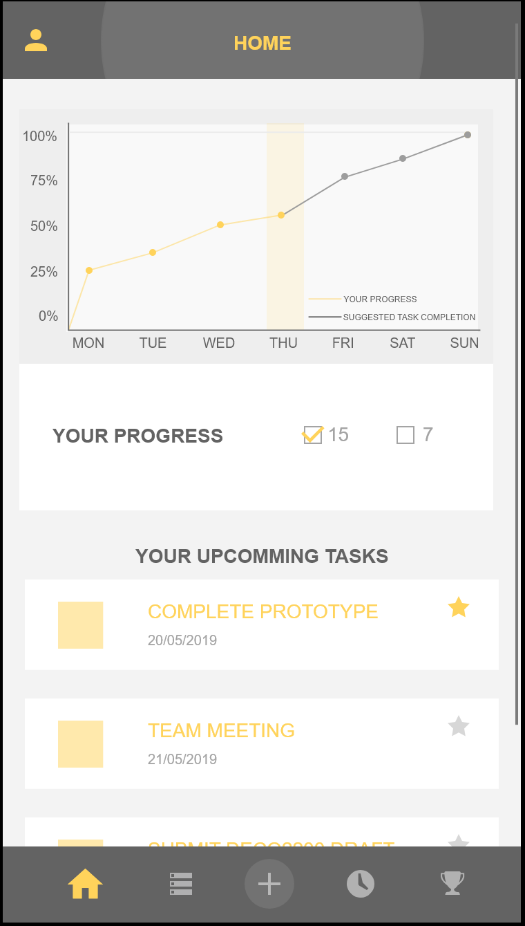

The home page is, routinely, the first point of interaction the user will have with the application. With that and the Ease-of-use design principle in mind, the team made the decision to design the home page in such a way that provides systematic insight into the application’s functionality and capabilities.

In doing this, the design aims to allow the user to seamlessly orientate themselves and their relationship with the system through utilising familiar visual organisation and displaying progress. To that end, the homepage presents an overview of the user’s progress as well as highlighting the week’s upcoming tasks. The design decision to feature the progress on the home page also feeds into a system requirement: “Positive progress is made readily available.” Thus, in order to adhere to this system requirement, the team highlighted the progress the user had made to date. This acts as a means to provide the user with feedback from the system in addition to a sense of validation and motivation to complete all set tasks.

Next, the decision to incorporate upcoming tasks on the homepage was made with respect given to the aforementioned Ease-of-use design principle as well as the system requirement to “make all tasks readily available to the user.” As the main purpose of the application is time, and subsequently task, management, it was identified that there was an apparent need to have all users tasks apparent upon first opening the application.

It is believed that maintaining a minimalistic visual organisation of this page will allow the user to easily digest how they are tracking as well as what needs to be done.

TASK PAGE

The task page has been designed with notable consideration given to the design principles of ‘Efficiency’ and ‘Ease-of-Use’ in addition to the system requirement of “minimising cognitive load”. With that being said, the task page has adopted a familiar metaphor based layout - a checklist. In utilising checklist-based visual organisation, the task page aims to provide the user with an easily navigable user experience. Additionally, efficiency is promoted as a result of the user’s ability to quickly and easily assume the necessary steps to successfully interact with the given functionality - checking off the task by using the checkbox. Indeed, the combination of the two aforementioned design principles contribute towards the system requirement of “minimising cognitive load”. The decision to utilise the checklist metaphor was solidified when the team explored the best means to reduce the user’s cognitive load. As this layout is already in the user’s long term memory, it takes very little effort to adjust to the system and engage with the available functionality. Indeed, the premise of the task page was to provide an easily identifiable and intuitive interface. 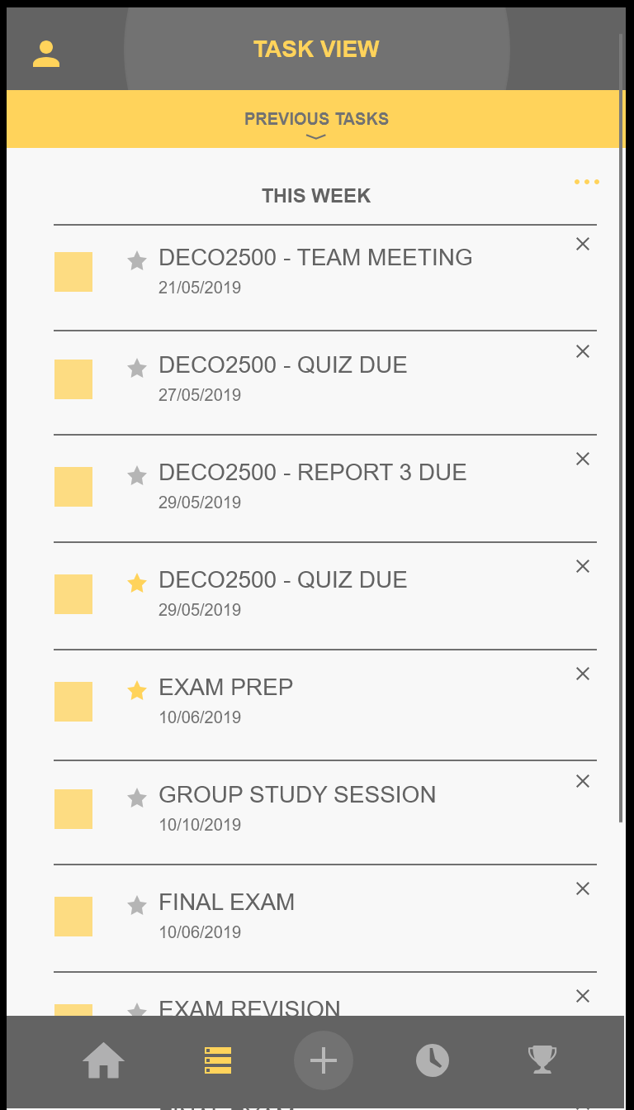

TIMER PAGE

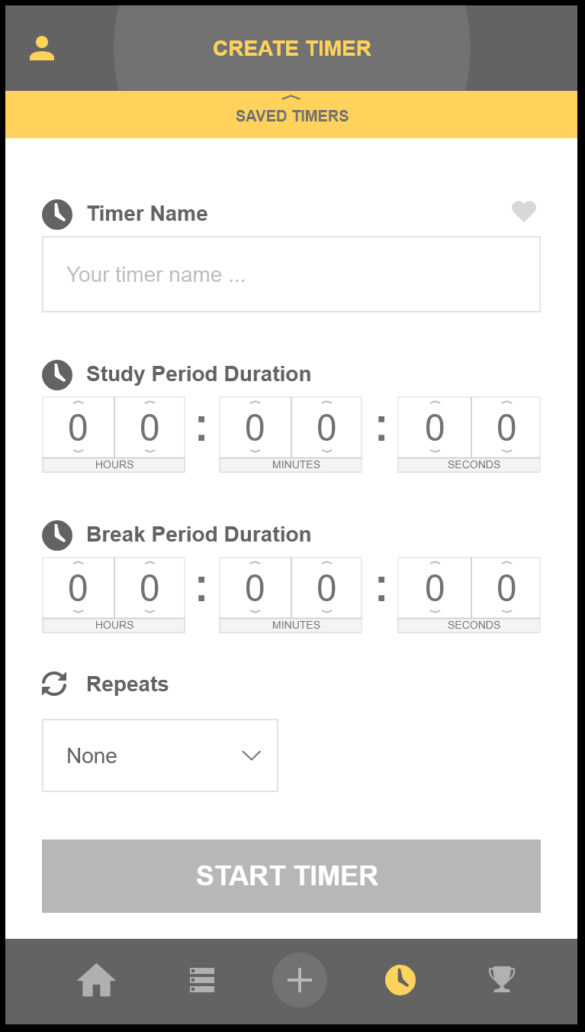

As the application is centred around time management, it was incredibly important to have functionality which directly facilitated the dedication and distribution of time. With that being said, when designing the timer page, the team gave consideration to the design principle: “flexible”, while also complying with the system requirements of “facilitating time management” and “allowing for the development of customisable tasks/ timers”. Indeed, it was identified that one of the most effective study techniques is scheduling equitable study and break periods (see Report 1, Establishing Requirements: Scholarly Articles) and thus, the application should facilitate this. In addition to specifying the name of the timer the user is given the opportunity to customise the duration of a study period and break period respectively. Further, the repeat functionality allows the user to study incrementally. Finally, the user is able to save the customised changes and use the timer again in future study sessions. Thus, the process of creating a customised timer aims to reflect a high degree of customisability and adherence to effective time management techniques.

## REWARDS PAGE

The achievement page was largely driven by the system requirements which aim to “provide motivation to stay on task” and “introduce incentives to promote continuous application usage.” As a result, the team incorporated an incentive system into the prototype. This system comprises predetermined weekly goals ranging from “complete one task before the deadline” to “study effectively for five hours.” The design of the achievements page utilises colour and Gestalt’s theory of similarity to indicate which rewards the user has ‘unlocked’ and which remain ‘locked’. Indeed, both of these system requirements are able to complement the “Challenging” design principle. With respect given to this design principle, the team aimed to provide the user with clear goals, consequently, a purpose when using the application - unlocking achievements. Thus, the design of the rewards page stemmed largely from the system requirements and design principles revolving around motivation and incentives.

## GENERAL

The application, as a whole, was designed with the core principles of being aesthetic and accessible to a broad user base. Thus, when designing for foundational layout of this prototype (colour, size, format) the team gave considerable weighting to what appeared to be visually pleasing. To that end, the accent of yellow in the colour scheme was selected as a result of its association to happiness and motivation - two emotions that would be ideal for the user to possess while interacting with the application. However, possibly more relevantly, the colours were chosen due to their ability to create effective contrast. The team was conscious of users with colour sensitivity/ blindness and thus chose to use colours which would not detract from the overall functionality and legibility of the application. Thus, the overarching design of the application aims to be aesthetic and accessible to the user.

## 

## SUMMARY

The process of developing the high-fidelity prototype allowed the team to represent the most current version of the application’s design in a near final version. Indeed, several iterations of the prototype were proposed and iterated upon before the team settled on the prototype which has been presented above. With that being said, the team is pleased with the current prototype, believing that it systematically and comprehensively represents the current conceptual design for the application. The software - Adobe XD - was able to allow for the seamless development of a high fidelity prototype. However, due to time constraints, the team was not able to fully implement every given pathway with the related context. Nevertheless, all functionality has been fully implemented and represented within the high-fidelity prototype, and will be able to facilitate a high level of interaction between the proposed system and end/expert-users.

# EVALUATION

## OVERVIEW

In determining the efficacy of the latest design, the team adopted many different evaluative techniques. In part to self assess the changes made so far, and in part to identify areas of future development and improvement.

In evaluating the design, three types of tests were conducted:

1. Pluralistic Evaluation - testing conducted by experts to extract detailed criticisms and areas for improvement not otherwise captured by testing users’ engagement with the design.
2. Heuristic Evaluation - testing conducted by experts to extract areas for improvement by comparing the design to a standardised set of heuristic goals against which other designs may be analysed.
3. User Evaluations (TAM, SUS, Task Time) - testing conducted by developers involving non-expert potential end users of the design to extract areas of trouble encountered by the users, and an overall evaluation of the design itself from the perspective of those directly interacting with the design.

These methods were utilised for different reasons as detailed below in their respective sections.

The team chose to test a total of 15 users, 3 of whom were considered experts in the field. This data creates a broad perspective and allows for patterns to be identified and anomalies to be made negligible. Further development of the areas identified as potential sites of improvement may be found in the “Establishing Requirements” section.

## PLURALISTIC EVALUATION

Part of the evaluation process was consulting with members of the design community outside our own development team.

This approach can yield results ordinary user evaluations cannot. By utilising the experience, knowledge, and perspective of outside and informed participants, issues that may not be detectable or quantifiable in other methods of testing may be identified.

Firstly, the third party designers were walked through the application from a user’s perspective, and conducted the same user-evaluation style procedure. Having conducted this walkthrough, they were asked to fill out a TAM and SUS questionnaire.

Secondly, in a round table like discussion a critical reflection on the app utilising the experience and knowledge of experts sets of fresh eyes was conducted. Notes were taken, and a substantial quantity of useful perspectives and advice was extracted.

## HEURISTIC EVALUATION

Additionally, the developers can extract useful information about the design by evaluating the prototype against a set of standardised heuristics, against which other applications may be assessed. For the purposes of this report and design process, the SMART-12 set of heuristic goals were utilised. (Credited to: Joyce et al. (2016) “Mobile application usability: heuristic evaluation and evaluation of heuristics” in *Advances in Human Factors, Software, and Systems Engineering*) (The full set of heuristics may be found in Appendix 2.5)

Heuristic evaluations are carried out by persons with experience in the field and thus provide a deeper analysis of the potential issues within the application design. The full methodology for the process of the heuristic evaluation is extensive and very time consuming, and involves at least five knowledgeable participants. Our team modified the process to allow for other methods of evaluation to be conducted.

This evaluation method was conducted as part of the pluralistic evaluation already covered. Firstly, the participants conducted the same walkthrough specified in the user evaluation section. Secondly, having conducted the critical engagement of the design as part of the pluralistic evaluation, the participants were asked to compare the design against the 12 SMART goals - providing details and justifications for each.

The issues outlined below will allow the team to propose further improvements before a final design is completed. These improvements will be discussed in greater detail in the “Establishing Requirements” section of this report.

## USER EVALUATIONS

The main component of evaluating the quality of the design involves engaging actual potential end users. By analysing how they interact with the design, and asking them for their honest opinions, areas of concern are found directly. In conducting these evaluations, the metrics employed to capture and quantify the quality of the design from the perspective of potential end users must be wide ranging and broad scoped; facilitate an analysis that is honest and critical; and yield results that aid in producing actionable improvements.

### Rationale for Chosen Metrics / Methodologies

#### (Quantitative) Time Taken and Task Completion and Note taking:

The quantitative components of user evaluations are used to extract a simple and direct assessment of what design components work well and as intended. If a user can accomplish a task, and do so in a short time frame, it stands to reason the user’s mental model matches closely to our design concept. In simply assessing the areas users take the most amount of time, asking what areas they struggled with, and how they viscerally felt about the design overall, outer layer (non-core concept) design components improvements may be found.

Throughout the testing, the facilitators observe the user’s facial expressions and body language, as well as device interactions to detect how the user is feeling on a surface level. After the testing procedure is complete, the facilitator may refer to their notes to enquire about specific moments or design components the facilitator suspects may be causing concern.

These methods are fast, easy, and yield concrete actionable ideas for improvement for design components that mostly relate to the effectiveness and communication of the design’s metaphors, signifiers, and affordances just to name a few. This first style may provide a vague numerical indication of how effective the design is, but concrete assessments about the more fundamental/core conceptual features of the design are difficult to extract with this method.

#### (Qualitative) TAM and SUS:

The qualitative perspectives a potential user may have require their own methods of evaluation. For this reason, the users conducting the evaluations are also asked to respond to more subjective qualities about the app, utilising a TAM and SUS questionnaire.

The TAM (Technology Acceptance Model) questionnaire is a series of positively worded statements the evaluating user responds to with a ranking from 1 to 4, with 1 being strongly disagree and 4 being strongly agree. (List of statements available in Appendix 2.3). It gauges perceived ease of use: the efficacy of the design’s approach to facilitating an interaction that is as easy as possible. If a user finds the design easy to use, the average responses will be closer to 4.

The SUS (System Usability Scale) questionnaire is a series of questions alternating wording positive and negative, for which the evaluating user answers by agreeing/disagreeing from 1 to 5. (List of statements available in Appendix 2.4) It gauges the degree to which a user considers the design acceptable, and likelihood of the user incorporating the design into their everyday life. After a statistical processing, an averaged grade is produced, roughly quantifying the acceptability of the design.

These methods have the benefit of being standardised (so individual responses may be compared, and statistical analyses may be conducted), while simultaneously capturing how each individual personally felt about the design in a way not measurable with stop watches or rulers.

These methods allow the development team to extract perspectives on changes made over the iterative process that can cover core conceptual components of the design as well as more surface level parts. These more conceptual areas a user can provide feedback upon, for example, may ask to what degree they think the app would help them with the problems the app is trying to address, or how enjoyable the found the overall experience.

### Evaluation Protocol

Like any scientific undertaking, variables must be controlled and taken into account. For this reason, the methodology for conducting the testing to achieve the kind of assessment the design team is looking for, must be a clearly defined procedure. A full copy of the evaluation protocol may be found in Appendix 1.

In essence, the walkthrough process asks the participants to complete a set of predetermined steps. The steps are chosen and ordered to emulate a typical use case, and are chosen to cover all areas of the design. The steps are ordered to enable each task to end where the next one begins. There is no feature of the design which does not have at least one step mandating user interaction. Throughout this process, the facilitator is observing and recording the metrics described above.

The prototype too, must not change between tests except for the most necessary of changes (such as implementation features exhibiting behaviour not part of the intended design).

Each testing user must also provide full and enthusiastic consent to engage with the testing, as the data obtained may only be useful if each testing user has the same understanding of what information they’re providing, and how it will be used. Signed consent forms may be found in Appendix 6.

## SUMMARY

In summary, the team has been able to identify specific problematic areas through this final iteration of the design cycle and as a result of final user evaluations. The evaluation methods chosen provide a broad set of data that give a clear insight into the performance of the application prototype during testing and potential improvements that can be made.

# 

# ESTABLISHING REQUIREMENTS

## OVERVIEW

Having conducted extensive evaluative testing on users and experts, this section will analyse the results and draw conclusions about potential areas of improvement. Incorporated into these conclusions will be feedback from previous rounds of prototyping, and existing design theory discussed earlier in this report.

## ANALYSIS

##### Pluralistic Evaluation

Part of the evaluation process was conducting a roundtable discussion with members of the design community outside this development team. The notes that identified areas of improvement will be addressed in future iterations of the design. So that the changes are effective, changes must utilise existing design theory, and be in accordance with the team’s design guidelines.

The provided notes are outlined below, and processed into actionable changes for future iterations of the design.

|  |  |  |  |  |
| --- | --- | --- | --- | --- |
| **+ve / -ve** | **App / Design Area** | **Notes / Comments** | **Potential Steps to Improve** | **Relevant Design Theory / Design Guidelines** |
|  | Introductory app tutorial | Useful and necessary feature. Rewatchability is also useful |  | Easy-of-use  User-centered |
| - | Introductory app tutorial | ”Rewatch tutorial” button hidden away and difficult to find. | Place the “Rewatch tutorial” button as discoverable as possible.. | Consistency |
| + | Overall app visuals / theme | Visuals are consistent and utilise contrasting colours. Appropriate typeface.  Visually appealing. Effective visual metaphors. |  | Accessible |
|  | Task / Timers list view | Checkboxes don’t resemble other examples of digital checkboxes. (Not clear / intuitive) | Utilising more user adaptable icon into the checkboxes | Easy-of-use |
| - | Navigation bar | Timers button should open to the timers list view, not ‘create timer’ view. Undermines the main ‘+’ button feature. Inconsistent with the tasks button (opens the task list view, not ‘create task’ view) | Link the ‘timer’ icon in the main menu to ‘previous saved timers’ | Consistency |
| + | Achievements feature | Provides good incentivisation. |  | Incentivising |
| - | Achievements feature | ”Achievement unlocked” pop up use of “dismiss” is ambiguous. Not sure if it means dismiss the pop up or dismiss the achievement itself. | Use more meaningful signifers to explain the action will be taken by users | Incentivising  Consistency |
| - | Task / Timers list view | Three dots (“...”) signifying “order by” difficult to find/see. | Utilising more user adaptable icon into the ‘order by’ function | Accessible |
| + | Navigation bar | Button layout is logical and consistent with other examples of navigation bars. |  | User-centered |
| - | Task list view | Marking importance of task should result in pop up with more relevant message than ‘task edited’. | Use more meaningful signifers to explain the action will be taken by users | Consistency |
| - | Achievements feature | Not clear how to unlock currently locked achievements - undermines incentivisation. | Provide notes to ‘Achievement’ to clarify each achievements | Incentivising |

##### Heuristic Evaluation

The table below provides a detailed summary of the SMART goals that were *insufficiently* addressed according to heuristic evaluations carried out by experts. Each problematic area is noted and deconstructed below, and its severity considered.

|  |  |  |  |  |
| --- | --- | --- | --- | --- |
| Need of Improvement SMART goals | | | | |
| SCREEN/ ELEMENT DESCRIPTION | USABILITY ISSUE | HEURISTIC CATEGORY | PROBABLE  EFFECT | SEVERITY RATING |
| Create Timer Page | Difficult to enter timer study/ break duration as a result of overly small input fields | Facilitate easier input by displaying keyboard buttons that are as large as possible, supporting,  multimodal input, and keeping form fields to a minimum. | Annoyance/ inaccurate interaction with interface | 1 (cosmetic problem)  Freq - rare  Imp - low  Persistent - not |
| Task View Page | No readily apparent option to reconfigure/ reorder tasks  (3 dots at top right of page will allow this, not obvious) | Allow configuration options and shortcuts. | Inability to engage with system on a higher/ more personalised level | 1 (cosmetic problem)  Freq - rare  Imp - low  Persistent - not |
| Whole application | Colour scheme could be difficult to see in some lightning. No consideration given to ambient noise when timer sounds | Cater for diverse mobile environments (lighting, ambient noise, gloves, etc). | Inability to see major elements of functionality in some lighting situations and inability to hear when timer sounds | 2 (minor usability problem)  Freq - rare  Impact - medium  Persistence - not |
| Create Task/ Create Timer Page | No way for visually impaired to enter data - should use microphone | Use camera, microphone and sensors to lessen user’s workload | Inability to interact with core functionality of the system | 3 (major usability problem)  Freq - rare  Impact - high  Persistence - high |

After consideration of these areas, recommendations have been formed to address these issues in future iterations. The ‘Create Timer Page’ in the final application should implement a scroll type interaction mode. This is a feature available on iOS and Android devices and thus would provide consistency with interactions the user is familiar with.

The ‘Task View Page’ needs to provide emphasis to the ‘order by’ feature, as users found that this was not readily apparent. This could be done by making the icon larger in size and altering the contrast of the colour selection.

To address the third improvement listed above, the team recommends implementing a vibration alongside the audible alert (at the end of a timer) in the final implementation of the design. Although an audible element is not currently implemented due to the constraints of the prototyping software, it is assumed this would be included within the final application.

Through this evaluation, it was also made clear that there were limited features that enabled ease-of-use for persons with visual impairment. It is recommended that features such as microphone and audible feedback be provided in the final product, particularly within sections such as the creation of tasks or timers.

The table below provides a detailed summary of the SMART goals that were *sufficiently* addressed according to heuristic evaluations carried out by experts.

|  |  |  |
| --- | --- | --- |
| Effective SMART goals | | |
| SMART GOALS | Effectiveness | Description |
| Provide immediate notification of application status |  | Progress page provides immediate feedback and status of interaction with system |
| Use a theme and consistent terms, as well as conventions and standards familiar to user |  | Navigation very familiar, consistent theme (colours, pop ups, data entry etc) |
| Prevent problems where possible, help users if problem occurs, including with network |  | Step by step data entry in create task/ timer to avoid invalid entry.  Notification of required fields when trying to progress without logging in |
| Display an overlay pointing out main features when appropriate or requested to help first time users |  | Initial tutorial and ability to replay tutorial at any time |
| Each interface should focus on one task, so that it’s glanceable to users who are interrupted frequently |  | Each page related to one task (ie create task page separate from create timer page) |
| Design a visually pleasing interface. Users ‘forgive’ attractive interfaces |  | Looks very sleek and visually attractive |
| Intuitive interfaces make for easier learning |  | Very intuitive, feels familiar (except checkbox) |
| Design a clear navigable path to task completion |  | Constant feedback and landmarks provided (ie page headers, popup context, highlighted navigation bars) |

### User Evaluations

For each of these metrics visual representations of the results and brief summary and analysis of each may be found below. These results will help inform the requirements for the design over the next iterative design cycle.

##### Task Time

As users completed the evaluation, the facilitator documented the time it took them to complete each of the set tasks. This information was averaged across the 15 testers and is represented in the graph below (raw data in Appendix 2.1). The completion time can be used to indicate which tasks users are taking longer to complete, further allowing the design team to ultimately narrow down tasks that are less intuitive to the user.

All benchmark results are faster than than the average user time, however this is to be expected: an expert will always be faster than a non-expert. The graph illustrates three potentially problematic tasks: the navigation of the tutorial, the creation of a task, and the creation of a timer.

The tutorial contains text and detailed annotation and thus, when read properly, the user will take a significant amount of time to reach the end of the tutorial. As with the other two identified tasks, both involve a data entry process in order to reach completion and thus would take the user significantly longer than a simplistic task. It is for these reasons that the team do not believe these tasks are problematic to the functionality of the application.

The team then identified the next potentially problematic task, making a task important. This took users an average of 9 seconds to complete, where the task only requires the selection of one area. We anticipated a shorter time to complete this task, as all that is required is clicking one symbol: no typing is required, and the desired action is no more than 3 clicks away from the screen the user should find themselves on at this stage, this is identified as a potential area for improvement. When discussing issues with users after they completed the task, it was common that users could identify the correct field to select, however the size of the selection field was not large enough to detect a touch easily.

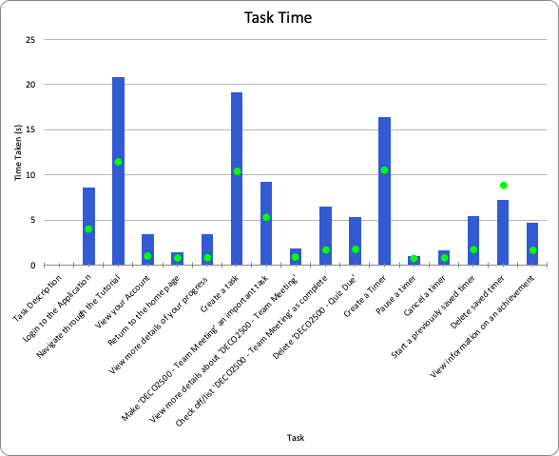

##### Task Completion Score

During the Task Time exercise, the facilitator also recorded a completion score which indicated whether or not the user was able to successfully complete each provided task. In this final stage of prototyping, all tasks completed by all users were listed as successfully completed.

This represents improvement to the navigation of the application, the task flow during testing, and the intuitiveness of the design, when compared to the results of this evaluation in the previous summary (see Report 2, Evaluation - Graph 1: Task Completion Score).

A visual representation of this most recent data, as well as the raw data are included in the Appendix section of this report (see Appendix 2.2 - Time Completion Score Data and Appendix 2.6 - Time Completion Score Graph).

##### 

##### TAM Questionnaire

The TAM questionnaire asked the evaluating users about how they felt on a more basic level about their assessment of the design overall.

*Average TAM Responses*

The graph below (next page) shows the average (mean) response to each question put to the user. Raw data for this visualisation available in appendix 2.3.

For a design that is 100% perfect, all responses would be rate the design at 4/4. Our design is averaging above well above 3/4. The lowest being just above 2.5/4 and the most enthusiastic rating just below 4/4.

Questions 1 to 6 concern the extent to which users agree the design helps the user accomplish their tasks more easily. Our design has an average score in this category approximately 3.25.

Questions 7-9 concern how easy to use the design is, and how easy it is to learn how to use the design. Our design succeeds the most in this category, averaging approx 3.75. One potential explanation for this elevated score could be the introduction of a tutorial. Some users took the time to read the tutorial, and some users commented on its usefulness (Appendix 7). The pluralistic evaluation also highlighted praise for its introduction.

Questions 10-12 concern how desirable the app is to the user, and the desirability of using the app. Our design has an average score in this category approximately 3.5. Since the last iteration of the prototype, an update of the design’s aesthetics and visuals has been implemented. The desirability of using the app speaks to the user’s desire thane a system that

Questions 13-15 concern the likelihood of future use of the design by the users. Our design performed poorest in this category, with an average score of approx 2.75. This area is of particular concern, as it speaks to how well the design addresses the identified problem it is trying to solve. The low score may be due to the fact the tested prototype is not a part of the user’s daily life - the tested prototype is on the facilitator’s computer and in a context removed from how the app would operate in-situ. By saying a user would not use the design, they’re answering they would *not use the design in its current form and context of use.*

## 

(This section left blank for formatting purposes)

*Distribution of TAM Responses*

The below visualisation demonstrates the distribution of the received responses. The distributive view of the data can highlight the extent of agreement/disagreement amongst participants about aspects of the design. Overwhelmingly, the responses were positive, with only a few 1s and 2s amongst the 3s and 4s.

The questions with the most disagreement are the areas asking about the possibility of future use by the evaluating user. This seems to support the claim made earlier that owing to the prototypical nature of the design. Perhaps the question is ambiguous, or perhaps our selection of potential users includes those with and without a need for time management support.

Users believe the design does solve it’s core identified issue (questions 1-6) with only 6 out of 90 responses in the first category suggesting the app does not address the core concern of the app.

Users overwhelmingly agreed that the app is easy to learn and adopt. Only 2 out of 45 responses suggesting the design is difficult to learn.

Raw data for this visualisation may be found in appendix 2.3.

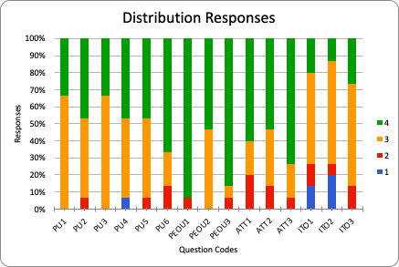

##### 

##### SUS Questionnaire

The SUS Questionnaire addresses many of the same areas as the TAM Questionnaire, however it does so asking differently worded questions, and in a way that prompts the evaluating user to think differently.

Again, the questions cover the same main areas as TAM, and as such, has resulted in data that correlates with the TAM results, if slightly exaggerating the differences between the categories.

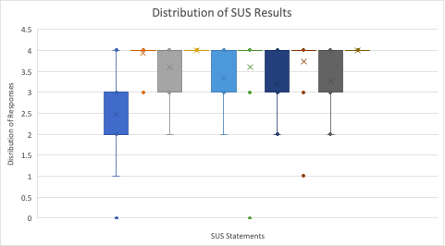

The graphic visualisation above provides a summary of the data collected during testing. Raw data for this visualisation may be found in Appendix 2.4.

This displays the overall acceptance of the prototype by tested users. It is clear that for all even numbered questions (ie every second question) majority of the values are close to 4, as evident by the coloured lines level with the ‘4’ response.

## 

## USER NEEDS AND GOALS

From the personas and interaction scenarios (See Report 2, Establishing Requirements - Personas and Interaction Scenarios), the team was able to develop the user needs in Report Two. These needs are an effective way to highlight the requirements the user would have established prior to interacting with the application. After these needs have been developed, subsequent user goals can be established. These goals are able to draw attention to user’s standards, consequently, elements of functionality that address these goals become apparent, Tables which indicate the progression of user needs and goals in addition to how and why the application addresses these goals can be seen below:

|  |
| --- |
| USER NEEDS: I want well structured study time |
| SUBSEQUENT USER GOAL: I want to remain on task to help boost my productivity |
| Application Feature: Application should allow user to start timer that keep user focus during the study period |
| Measure: User interviews |
| Source: “I want to remain on task to help boost my productivity” (Report One, Appendix 1) |

|  |
| --- |
| USER NEEDS: I want to see what I have done |
| SUBSEQUENT USER GOAL: I want to view my progress to help motivate me |
| Application Feature: Application generates progress bar of user usage weekly |
| Measure: User testing |
| Source: “I want to view my progress to help motivate me” (Report One, Appendix 3) |

|  |
| --- |
| USER NEEDS: I want to schedule study intervals |
| SUBSEQUENT USER GOAL: I want to be able to achieve my study goals |
| Application Feature: Application should allow user to import study period duration and break period duration |
| Measure: Survey |
| Source: “I want to be able to achieve my study goals by effective way”(Report One, Appendix 5) |

|  |
| --- |
| USER NEEDS: I want to be reminded to study |
| SUBSEQUENT USER GOAL: I don’t want to forget about my upcoming assessment |
| Application Feature: Application should provide notification settings for upcoming tasks |
| Measure: Survey |
| Source: “I don’t want to forget about my upcoming assessment”(Report One, Appendix 5) |

|  |
| --- |
| USER NEEDS: I want to prioritise my tasks |
| SUBSEQUENT USER GOAL: I want to be more organised for my assessment |
| Application Feature: Application should allow user to set importance of tasks on the list |
| Measure: User testing |
| Source: “I want to be more organised for my assessment”(Report Two, Appendix 2) |

|  |
| --- |
| USER NEEDS: I want to ‘want’ to study |
| SUBSEQUENT USER GOAL: I want to be motivated to study |
| Application Feature: Application should develop the motivation page that rewards user while user using our application(e.g. Usage Counter) |
| Measure: User testing |
| Source: “I want to be motivated while using the app, so I will use it in a regular basis in the future more possible.”(Appendix 2) |

## POSSIBLE FUTURE DIRECTION/IMPROVEMENT

|  |
| --- |
| MAJOR FEATURE: APPLICATION ALLOW USERS TO SYNCHRONIZE THE DATA WITH ANOTHER APPLICATION |
| Secondary Feature: The functionality of our application should include the synchronization of data from another application including the task management function e.g. google calendar |
| Rationale: Data sync is way to be effective then users with more time to do the work that matters most |
| Notes: Users are looking for apps that sync with other tools in order to automate as much of your task management as possible.(Aston. B. ,2018) |

|  |
| --- |
| MAJOR FEATURE: APPLICATION APPLY INTUITIVE INPUT METHOD |
| Secondary Feature: Entering timer data facilitates easier input by displaying keyboard buttons that are as large as possible, supporting, multimodal input, and keeping form fields to a minimum. |
| Rationale: Experts feel unintuitive slider to enter time duration |
| Notes: Using slider to enter time duration is way to finicky, user may feel unintuitive (Heuristics Evaluation) |

|  |
| --- |
| MAJOR FEATURE: APPLICATION SHOULD ALLOW MULTIPLE WAYS OF INPUT |
| Secondary Feature: Use camera, microphone and sensors to lessen user’s workload |
| Rationale: Inability to interact with core functionality of the system which is unethical for blind user(Ethics and HCI from lecture 2) |
| Notes: Based on the feedback of Heuristics Evaluation, user reports that there is no way for visually impaired to enter data - should use microphone(Heuristics Evaluation) |

|  |
| --- |
| MAJOR FEATURE: APPLICATION SHOULD UTILISE MORE MEANINGFUL ICONS |
| Secondary Feature: The icons in the application should tell the users what actions it will be. Like the ‘order by’ icon should be replaced by icons related ordering. |
| Rationale: the good using of icons can be interpreted meaningfully and help people understand. |
| Notes: User feels “three dots (‘...’) signifying ‘order by’ difficult to find/see” (pluralistic evaluation). |

|  |
| --- |
| MAJOR FEATURE: APPLICATION SHOULD INCLUDE PREMIUM STATISTIC FEATURE |
| Secondary Feature: Statistic feature can analysis usage progress from users for a longer time e.g. months or any period time users want. |
| Rationale: Running analytics provide user a clear view of user time spending on tasks and find out areas where to cut cost of time. |
| Notes: Progress bar encourages time attitudes initiated that they had much more time to finish their everyday jobs because they experience more in control of how their time was exhausted therefore knowing where user can cut time spending (Nasrullah. S & Khan. SM, 2015) |

## SUMMARY

After analysing the datas obtained from heuristic evaluation, pluralistic evaluation, TAM and SUS of the high-fidelity prototype, the team was able to locate possible future directions / improvements in need of further consideration and further updated the user needs and goals.

# CONCLUSION

This report aims to detail the team’s third cycle of the Interaction Design Process. As a result of the feedback obtained over the duration of this linked report, the team has developed and extended upon design alternatives, the prototype and the evaluation process. The team has been able to identify areas for future improvement and has detailed requirements that should be addressed in possible future development of the application. These include the addition of more familiar data input methods (scroll to select time), the options to customise notification settings, as well as a better adherence to usability requirements through utilising the microphone and speakers to input and relay information to the user. With that being said, recommendations have been made, with respect given to the requirements, in order to better the Focus’ performance and promote a more cohesive human-computer interaction. Indeed, the team’s ability to adhere to the Interaction Design Process was a largely a result of the conscious effort that was made to maintain communication with the end users. This decision provided the team with a solid understanding of the users’ conceptual model, which made the design and development of the high-fidelity prototype a relatively seamless process. Further, the communicative avenues established with the tutors was able to provide insight and possible means for improvement regarding the team dynamics. Nevertheless, Trooperz are extremely proud of the application which has been designed, and believe it actively addresses the chosen domain of behavioural change. The application aims to improve the user’s study efficiency through targeting time management. Each design decision has been justified by design theory, scholarly research, or data obtained by the end users. Trooperz has made it our mission to help people to *Focus*.

# 

# REFERENCES

Aston, B. (2018). *The Best Productivity Apps: Boost Your Productivity In 2019.* From the digital project manager:

<https://thedigitalprojectmanager.com/best-productivity-apps-tools/>

Babich, N. (2016). *Progress Trackers in UX Design*. From UX Planet: <https://uxplanet.org/progress-trackers-in-ux-design-4319cef1c600>

Clover, J. (2019). *How to Use Screen Time in iOS 12*. From MacRumors: <https://www.macrumors.com/how-to/how-to-use-screen-time-in-ios-12/>

Encyclopaedia Britannica. (2019). *Gestalt psychology*. From Encyclopaedia Britannica: <https://www.britannica.com/science/Gestalt-psychology>

Interaction Design Foundation . (2018). *Design guidelines.* From Interaction Design Foundation : <https://www.interaction-design.org/literature/topics/design-guidelines>

Interaction Design Foundation . (2018). *Fitts Law*. From Interaction Design Foundation : <https://www.interaction-design.org/literature/topics/fitts-law>

Interaction Design Foundation. (2018). *Intuitive Design*. Retrieved from Interaction Design Foundation: <https://www.interaction-design.org/literature/topics/intuitive-design>

Interaction Design Foundation. (2019). *The Pareto Principle and How to Be More Effective*. From Interaction Design Foundation: <https://www.interaction-design.org/literature/article/the-pareto-principle-and-how-to-be-more-effective>

Kizer, N. (2017). *Pink Bows and Twinkle Toes*. From Pinterest: <http://blog.questia.com/2015/09/your-7-step-research-paper-checklist-so-you-meet-the-grading-criteria/>

Mindtools. (2017). *What Is Time Management?* From Mindtools: <https://www.mindtools.com/pages/article/newHTE_00.htm>

Nasrullah. S & Khan. SM, (2015). The Impact of Time Management on the Students’ Academic Achievements, *Journal of Literature, Languages and Linguistics*, Vol.11, From Research Gate:

<https://www.researchgate.net/publication/313768789_The_Impact_of_Time_Management_on_the_Students'_Academic_Achievements>

Norman, D. (2013) *The Design of Everyday Things.* From UQ Library: <https://ebookcentral-proquest-com.ezproxy.library.uq.edu.au/lib/uql/reader.action?docID=1167019>

Samsung. (2018). *Samsung Galaxy s9*. Retrieved from Samsung: <https://www.samsung.com/au/smartphones/galaxy-s9/>

Snapchat. (2016). *Achievements*. Retrieved from Snapchat: <https://www.snapchat.com/>

Teixeira, F. (2019). *UX Collective*. From UX Design: <https://uxdesign.cc/>

# 

# APPENDIX

## APPENDIX 1: EVALUATION PROTOCOL

**Evaluation Protocol**

|  |  |
| --- | --- |
| **EvaluationID** | Focus User Test 003 |
| **Aims** | 1. Identify any remaining problems revolving around the functionality 2. Identify any remaining discrepancies between user’s mental model of the application and the available functionality 3. Identify any remaining user motives and needs |
| **Dates** | 18/05/19 - 24/05/19 |
| **Creators** | Jessica Rock and Michelle Owen |

**Preparation before the participant arrives:**

Materials needs:

1. Consent forms
2. Observation sheets
3. Task List
4. Excel Spreadsheet (TAM, SUS, Task Completion Score, Task Completion Time)
5. High-fidelity Prototype

**Introduction**

The facilitator is to introduce themselves and thank the user for their willingness to participate in this evaluation of the design. The facilitator is to describe the Design Project and how the team has been tasked with creating an application which targets a given domain (in the case of Trooperz, behavioural change). Next, the facilitator will introduce the application - Focus, and describe its intended purpose to improve the user’s study efficiency through targeting time management. The facilitator will detail how the session will unfold and how the tester’s evaluation of the design will be monitored. Finally, the facilitator will stress the importance and beneficial nature of communication and honestly through the evaluation period.

**Consent**

The facilitator will provide the user with a consent form before the commencement of testing. The user will be given the opportunity to read the form thoroughly and sign it if willing to participate. The user will be informed that they may revoke their consent at any point in the future. All consent forms are included in the Appendix 6

This testing will be carried out to evaluate the interaction with Focus that is currently in development. The aim is to evaluate the design as well as the ways in which users interact with the application. Be sure to remember that throughout this process, you are not being evaluated, but instead that software that has been created. Any questions, prompts, or other discussions are conducted directly for the purpose of improving the current design. It is important that you remain completely honest throughout the testing, and don’t be afraid to voice your thoughts and opinions.

The testing will be conducted as a series of tasks which you will be given and asked to complete to your best ability. Each task will be timed from when the task is given to the moment you either complete the task or state that you ‘give up’. Should the user choose to “give up”, or there is an apparent difficulty in task completion, the user will be asked to identify the root of the problem and specify any relevant adjustments they believe could be made to improve the platform.

The user will then be made aware that the order of tasks aims to follow an intuitive flow. Thus, the user is not expected to return to the home page upon completion of the task and, instead, continue evaluating the design from the page currently in use. Finally, the user will be asked if they understand the expectation of this evaluation period:

Do you understand what I want you to do? Good.

Are you ready? Here is the first task I would like you to complete…(state task).

This is the format that will be used to deliver each task. The last instruction will be repeated for each of the tasks listed below.

1. Login to the application
2. Navigate through the tutorial
3. View your account
4. Return to the home page
5. View more details about your progress
6. Create a new tasks
7. Make ‘DECO2500 - Team Meeting’ an important task
8. View more details about ‘DECO2500 - Team Meeting’
9. Check off/list ‘DECO2500 - Team Meeting’ as complete
10. Delete ‘DECO2500 - Quiz Due’
11. Create timer
12. Pause timer
13. Cancel timer
14. Start a previously saved timer ‘Short and Sweet’
15. Delete a saved timer
16. View information on an achievement

The facilitator will make observations and record data as the user completes this process.

Following this, the facilitator will provide the next task and this process will be repeated until every task is completed in this way. It is important to note that during the timed iteration of the task, the facilitator will not talk, discuss, or prompt the user in any way, simply observe and record data. Finally, during this testing process, the facilitator will record for each task whether or not it was successfully completed.

Following this, the user will be asked to complete a TAM and SUS evaluation based on their experience using the medium-fidelity prototype.

*Notes to facilitator:*

Prompting questions to be used:

1. What are you thinking now? (particularly if the participant stops talking)

2. Why did you do that?

3. How do you think [insert problem area] could be improved?

**Task 3: Interview**

Interviews will be conducted upon the conclusion of the formal testing period.The tester will be required to complete a SUS and TAM evaluation in order to systematically gauge the tester’s response the the application’s design. However, in order to obtain a more in-depth insight into the user’s unique responses, the facilitator will ask the tester personalised questions revolving around their respective issues encountered and evident frustrations.

**Closing**

Once the test has concluded, thank the tester for their time and effort. Then, the facilitator is to reiterate the tester’s right to refrain from having their data featured within the report.

## 

## APPENDIX 2: RAW DATA

**blue highlighting is used throughout this raw data to identify which testers were experts (pluralistic data)

Appendix 2.1 - Task Time Data

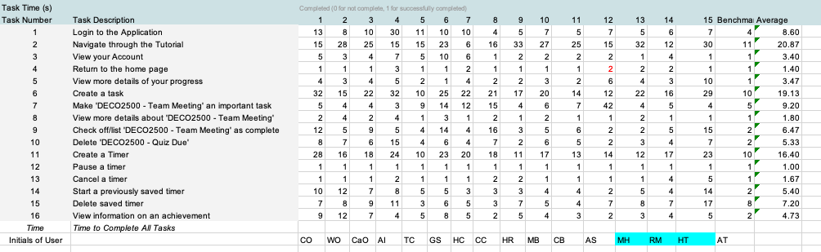

Appendix 2.2 - Task Completion Data

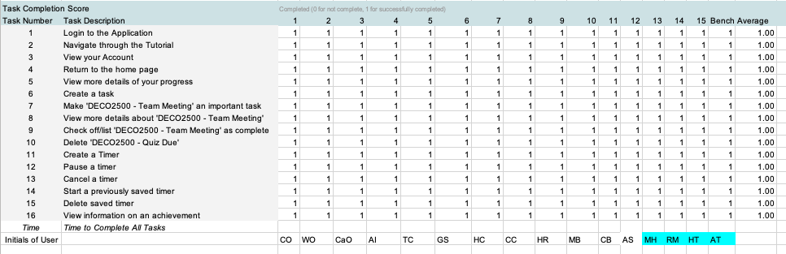

Appendix 2.3 - TAM Evaluation Data

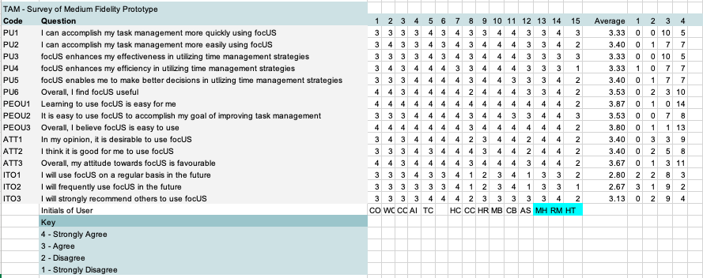

Appendix 2.4 - SUS Evaluation Data

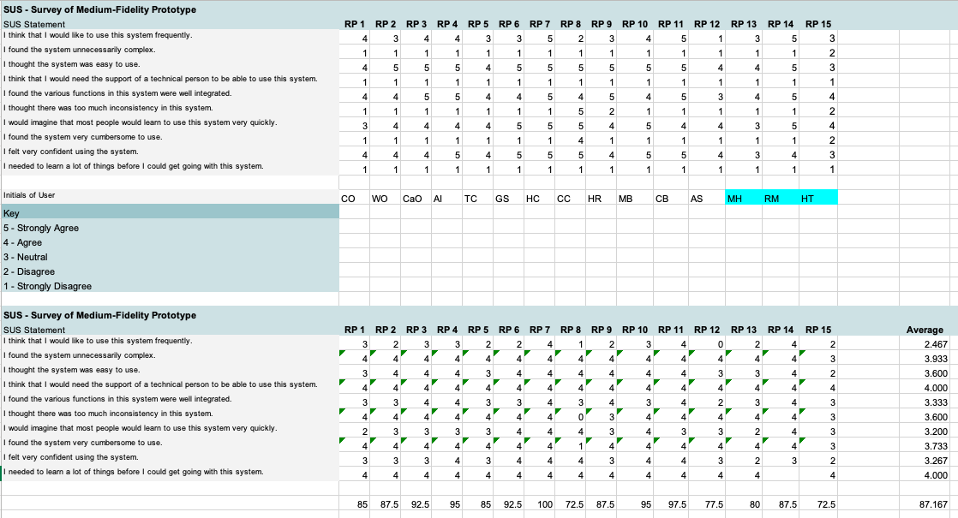

Appendix 2.5 - Heuristic Evaluation Data

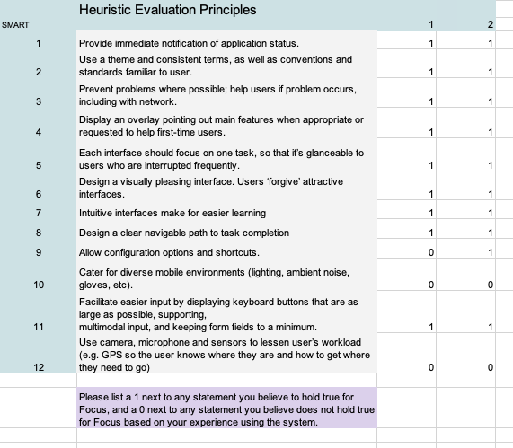

Appendix 2.6 - Task Completion Score Graph

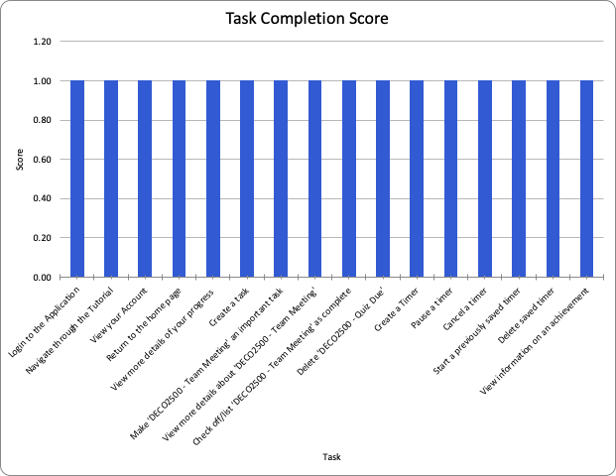

## 

## APPENDIX 3: RESPONSE TO FEEDBACK SUMMARY

This report aims to provide clear and concise information to the client regarding the proposed design. It is important that provided feedback on previous design iterations as well as formal feedback provided, in this case from previous reports. Below is a summary of how the team has aimed to address the provided feedback.

INTRODUCTION:

* No formal feedback provided.
* Still aim to provide a concise overview of:
  + How report 3 progressed
  + Where the team is in relation to the Interaction Design Process
  + Any major issues/ decisions that had to be made in this stage of the report

PROCESS DESCRIPTION:

* No formal feedback provided
* Still aim to provide a comprehensive overview of each section of the report through:
  + High level summary of the process undertaken at each stage of the Interaction Design Process
  + Any major decisions/ issues encountered at each stage

DESIGNING ALTERNATIVES:

* Improve rationales for why change is necessary
* Explanation of concepts is necessary, such as interaction paradigms, before discussing in detail
* Metaphors needed greater explanation
* Subjective language should not be used.
* Add the definitions of interaction paradigms to give reader a concise explanation of the meaning of a word or phrase or symbol.
* Including more linking back to the evaluation datas we gathered from previous report.

PROTOTYPE:

* To reduce the cognitive load even further. Annotations for the high-fidelity prototype were places next to the screenshot of the relevant page.
* Evaluation of existing applications no longer used as justification for the prototype
* Have now described how this prototype is a good representation of your design alternatives section through linking back to your design guidelines and system requirements. This demonstrates how the team has considered the intended design and how that has been reflected in your prototype.
* Protocol moved to the evaluation

EVALUATION:

* Aim to explain in detail each of the evaluation methods and the reasoning for selected each one.
* Narrow down what is important in this section; overview, description of each method and its purpose, and then evaluation protocol
* Aim to discuss the tasks that were chosen within these particular methods and why they were chosen
* Explain what the results mean and what they say about the user’s experience.
* Feedback from protocol in prototype
  + What is TAM? SUS? Why are you using them as evaluation methods
  + No adequate description of any of the methods. No adequate reasoning behind ordering of the protocol. No valuable discussion around the chosen tasks to be completed in methods.

ESTABLISHING REQUIREMENTS:

* Aim to provide more reference data to justify personas and interaction scenarios
* Aim to provide more links to data collected throughout evaluation methods
* Include reasoning for the importance of UX Goals
* Requirements in need of improvement need to link back to data
* Most important part of this section is the ‘notes’ section of the table, and making sure there is no subjective language or opinionated conclusions

CONCLUSION:

* Positive feedback obtained
* Still aim to provide a relatively high level summary
  + How and why the prototype was developed
  + How/ why it performed the way it did
  + Where the application could go in future development
  + Restate purpose

EVALUATION PROTOCOL - APPENDIX

* Positive feedback obtained

TEAM EVALUATION - APPENDIX

* Going forward objectives should be dated

## 

## APPENDIX 4: HIGH-FIDELITY SCREENSHOTS

|  |  |
| --- | --- |
| SCREENSHOT | PAGE NAME |
|  | Sign In Page |
|  | Profile Page |
|  | Tutorial Popup |
|  | Home Page |
|  | Create New Popup |
|  | Progress Page |
|  | Task View Page |
|  | Previously Completed Tasks Page |
|  | Task Completed Popup |
|  | Create Timer Page |
|  | Running Timer Page |
|  | Saved Timers Page |
|  | Timer Paused Popup |
|  | Achievements Page |
|  | Achievements Popup |
|  | Achievement Unlocked Popup |
|  | Notification Popup |
|  | Relationships |

## APPENDIX 5: TEAM EVALUATION

#### Appendix 5.1 - Team Charter

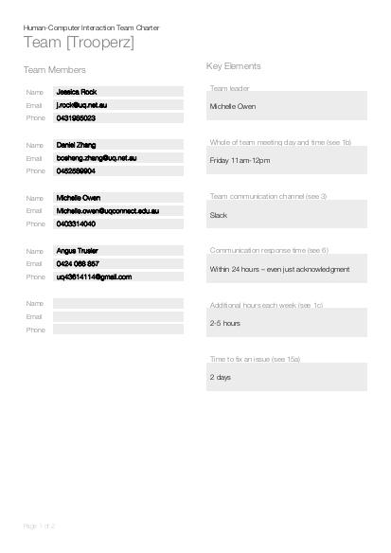

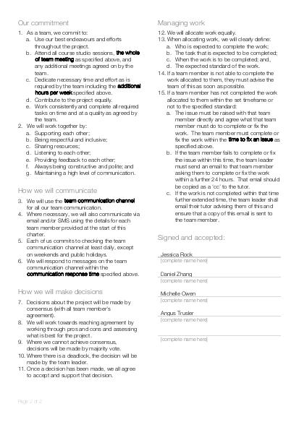

#### Appendix 5.2 - Team Meeting Logs

The team has made a significant effort to document team meetings and work allocations throughout the production of this design report. The rough logs are included below for reference. The team feel that they have managed to document deadlines and set goals more efficiently in this report in comparison to the previous reports.

*Studio Session Friday Week 11 (17th May)*

* Daniel and Angus worked on Designing Alternatives
* Michelle worked on Prototype Protocole
* Jess worked on Prototype
* Report 3 allocations were altered, Angus is now responsible for the Evaluation
* The team discussed the allocations and load distribution
* The team has agreed to aim to have as much as possible completed by Friday of Week 12

Going forward:

* The team aims to complete the prototype by Saturday 18th/Sunday 19th
* The team aims to start collecting data before the commencement of Week 12
* The team has discussed the importance of regular communication as the submission data draws closer

*Meeting Tuesday Week 12 (21 May 2019)*

*Angus absent from meeting

* Went through all feedback from report 2 together
* Discussed current progress with report 3
* Discussed tutor discussion from Friday and the need for equal contribution

Aim to complete by Friday (24th May):

* Daniel to do the annotation of design/interactive element description, testing
* Jess needs to re-do task flow and process data when complete and protocol, testing, read through conc, intro, process desc. And leave comments
* Michelle protocol, testing, conclusion, read through of report

(all above tasks were completed by the Friday studio)

*Meeting Tues 28th May*

* Discussion on Report 3 progress to date
* Decisions on submission method – team has agreed to have the Report 3 document complete by the Week 13 Studio, then during the studio, the document will be formatted, and completed and submitted within that time.
* Completed (not proofed) sections: Introduction, Process Description, Prototype, Designing Alternatives, Conclusion (to be finalised)
* Further Requirements – Daniel
* Angus – Complete evaluation and establishing requirements

Going forward:

* Evaluation section – elaborate on each method, sampling size choice, what went wrong with the evaluation (pluralistic was only with 2 people), what worked well, data visualisation reasoning (why its graphed like that), identify patterns, then link to est. requirements for further details, recommendations for further evaluations
* Est. Requirements – reference evaluation (after completion),
* Response to feedback in Appendix (all group members to contribute for their sections)

Appendix 5.3 - Report 3 Work Allocation

|  |  |  |  |  |
| --- | --- | --- | --- | --- |
| **SECTION** | **TASK** | **TEAMMATE COMPLETING** | **COMPLETION DATE (2019)** | **STATUS** |
| GENERAL | Establish changes made to prototype and rationale behind decisions | Whole team | 13/05  10 am |  |
| INTRODUCTION | Write the introduction | Michelle | Aim: 28/05  Completed: 21/05 |  |
| PROCESS DESCRIPTION | Write the process description | Michelle | Aim: 28/05  Completed: 21/05 |  |
| DESIGNING ALTERNATIVES | -Update Conceptual Design Statement  -Update design principles  -Update System Requirements | Daniel and Angus | Aim: 21/05  Completed: 28/05 |  |
| PROTOTYPE | Develop a high-fidelity prototype | Michelle and Jess | 17/05 |  |
| PROTOTYPE | Write protocol | Michelle and Jess | 15/05 |  |
| PROTOTYPE | User testing | Whole team  (15 responses) | 21 or 22/05 |  |
| GENERAL | Establish changes that would be made to the design | Whole team | 21/05  11 am |  |
| PROTOTYPE | Write the process of prototype development | Michelle | Aim: 28/05  Completed: 20/05 |  |
| PROTOTYPE | Develop task flow | Jess | Aim: 28/05  Completed: 20/05 |  |
| EVALUATION | Input and summarise all data obtained by testing | Jess - now Angus(17th)  *(now Jess too - 28/05)* | Aim: 23/05  Completed: 31/05 |  |
| ESTABLISHING REQUIREMENTS | Analyse data collected and make decisions on the App. system and include rationale for these decisions | Angus | Aim: 23/05  Completed: 31/05 |  |
| ESTABLISHING REQUIREMENTS | Update user needs/ user goals | Daniel | 24/05 |  |
| ESTABLISHING REQUIREMENTS | Possible future direction/ improvements that would be made | Daniel | 26/05 |  |
| CONCLUSION | Write the conclusion | Michelle | Aim: 28/05  Completed: 21/05 |  |
| REFERENCES | Compile/alphabetize sources | Daniel | 28/05 |  |
| APPENDIX | Compile/ sort references for Appendices | Angus (not done)  (Jess & Michelle completed) | 28/05 |  |
| DOCUMENT DESIGN | Make headers/ title page | Michelle | 12/05 |  |
| EDITING | Edit/ proofread document | Michelle | 30/05 |  |

#### Appendix 5.4 - Team Progress Summary

The team has worked well together to present this report as a means of detailing the final design iteration. The high-fidelity prototype was completed in good time, which allowed the team to carry out detailed testing and gather a plethora of results. This development did take a significant amount of time, due to the scale of the application and the limitations of the software being used. The team made an executive decision to implement all functionality, however, repeated instances may return the same result instead of minor differences. This decision allowed the team the opportunity to test the prototype on schedule, further allowing the data processing to be completed on on-time (as per the team’s initial deadlines).

The team believes that improvement has occurred within the team for this report and that tasks are more evenly distributed amongst the group than in the previous report. It is acknowledged that this has been something that the team has been working on since report 2. The team made an effort to address this by discussing fair work load and task distribution and re-allocated tasks where necessary.

It must be noted that the team still needs to develop their time management and ensure that tasks are completed on time. This has been an issue the team has addressed but acknowledge there is still room to improve.

In summary, the team is satisfied with their progress and their ability to have overcome this issue and are happy to have produced a well-thought-out and highly researched application design.

## APPENDIX 6: CONSENT FORMS

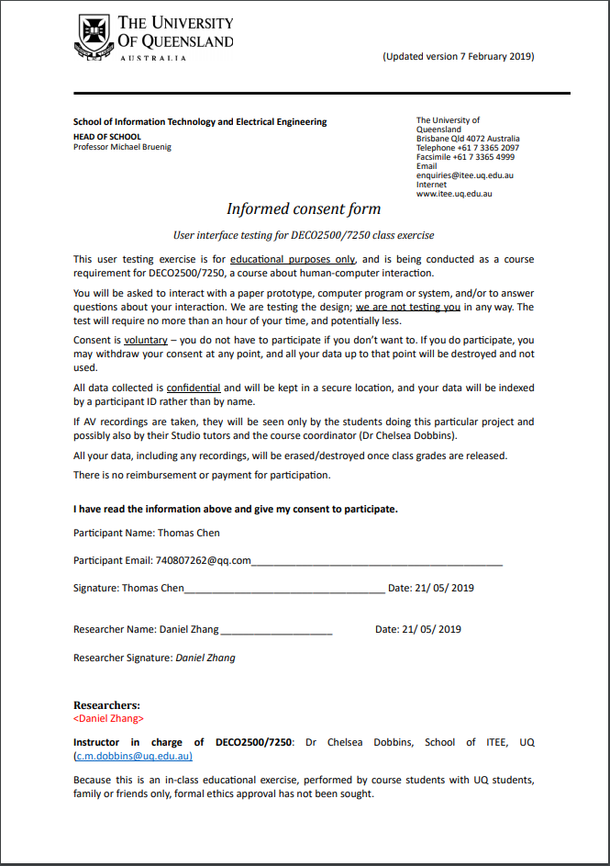

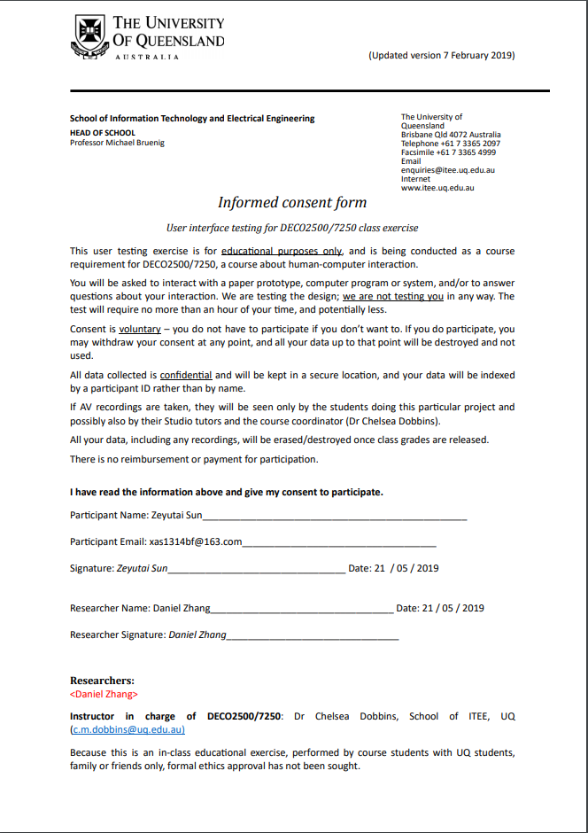

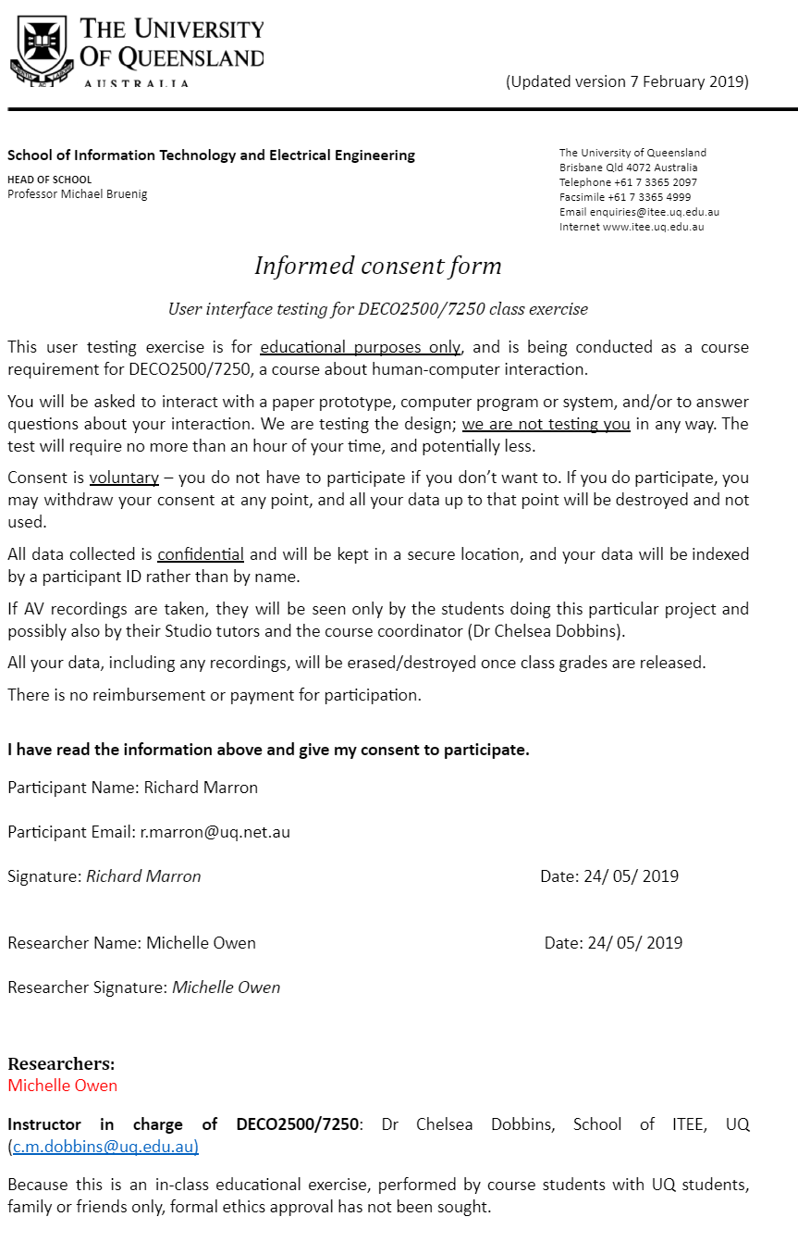

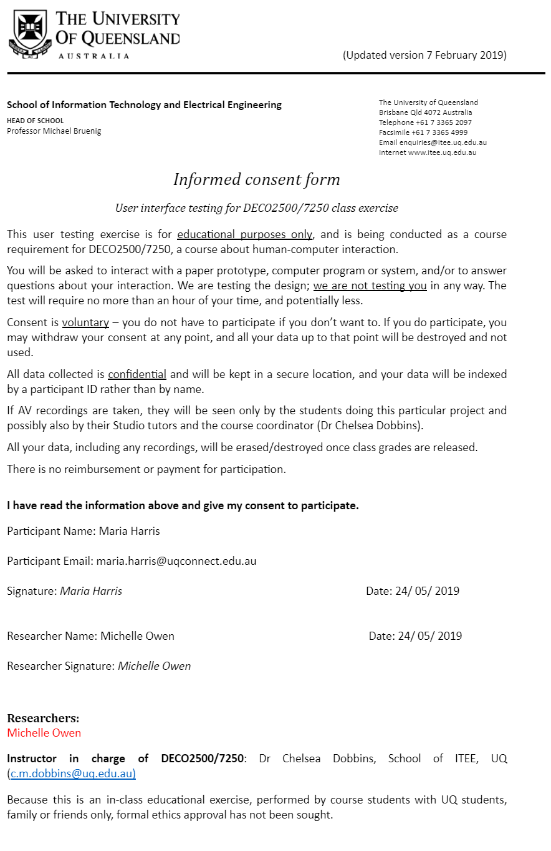

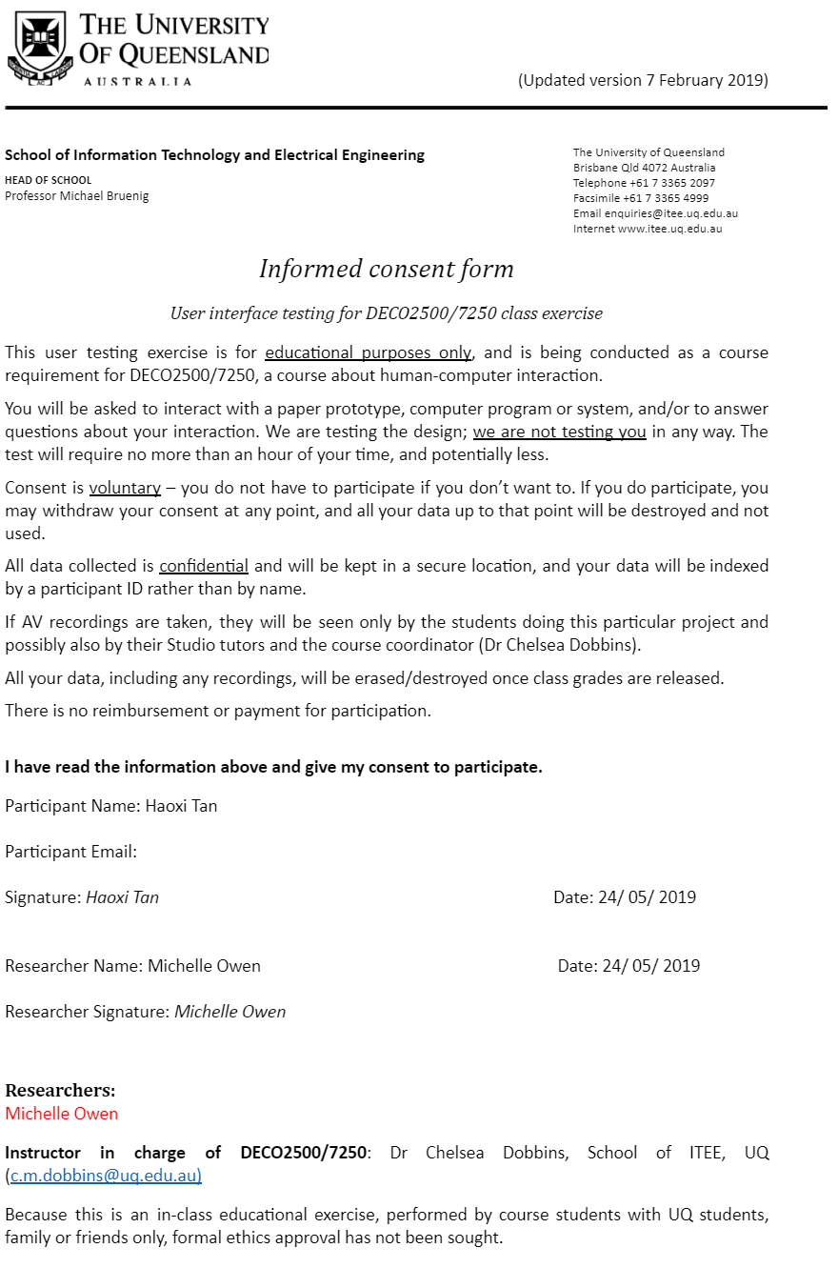

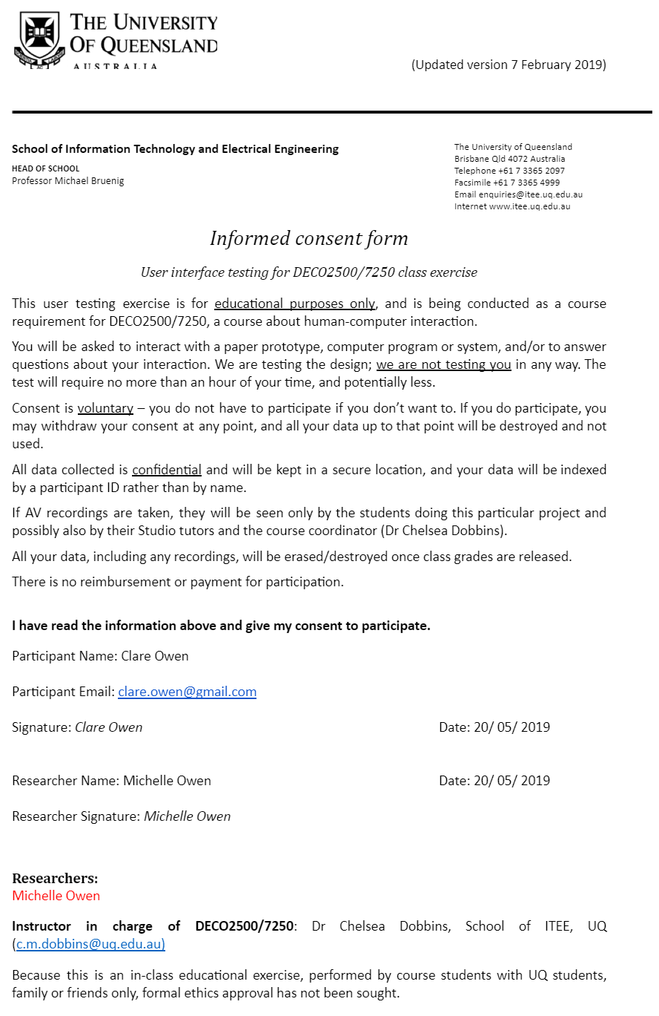

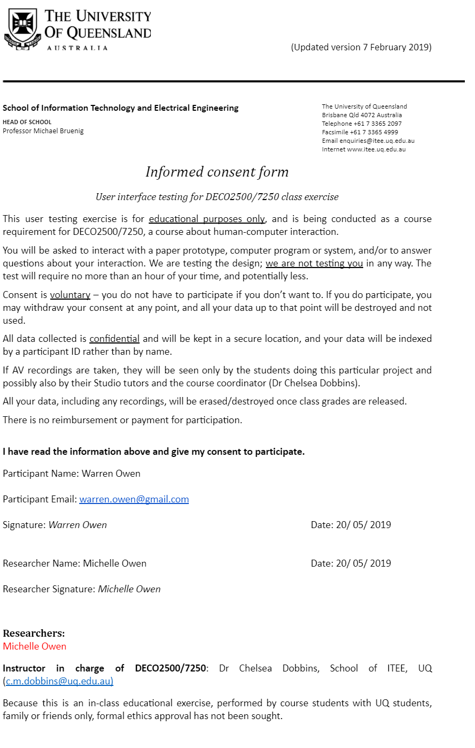

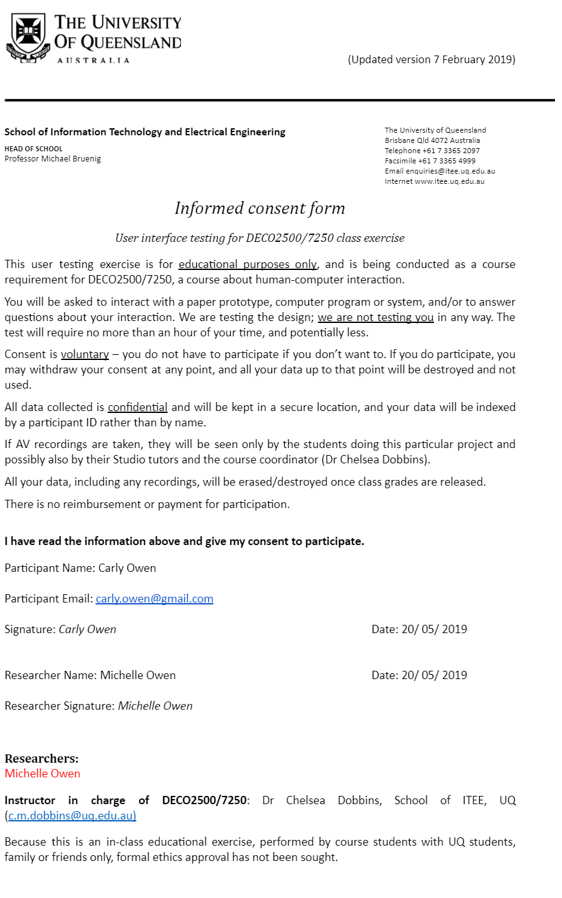

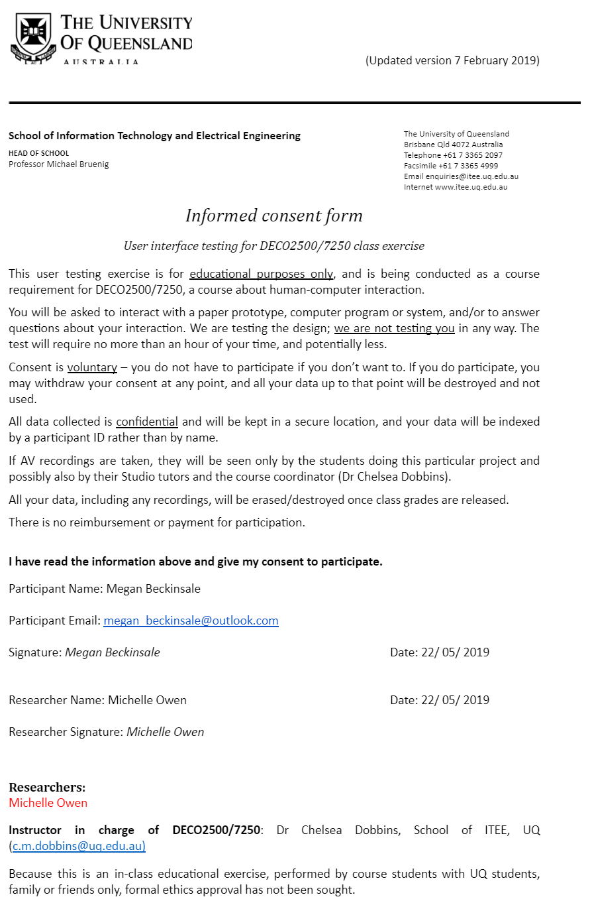

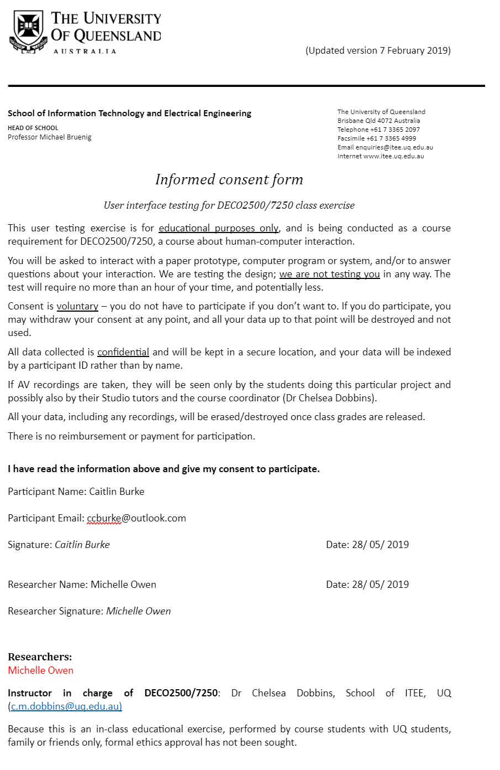

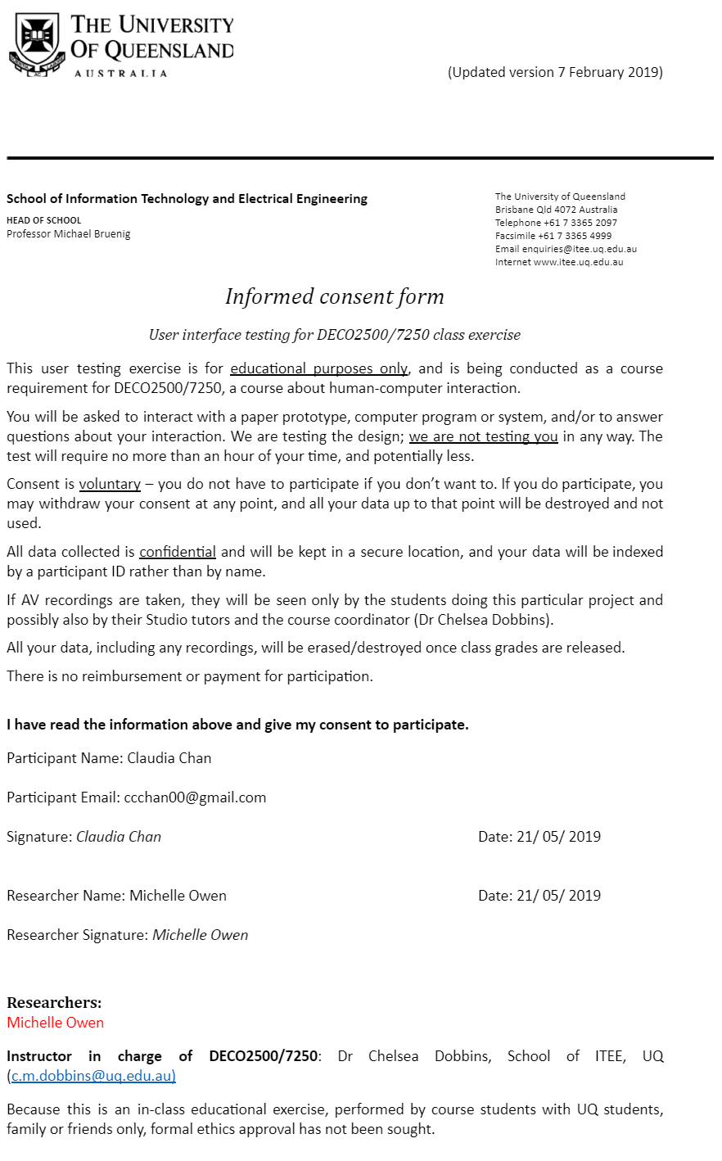

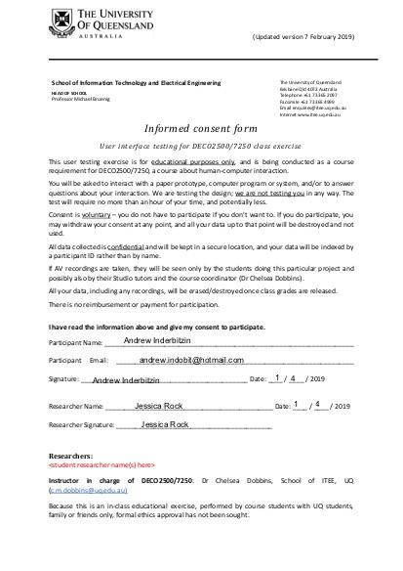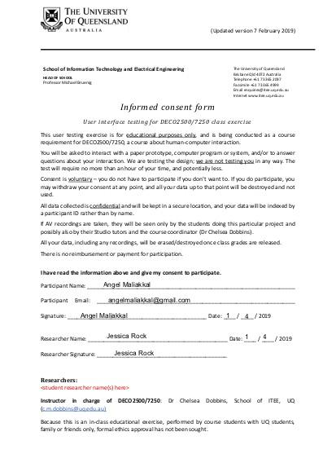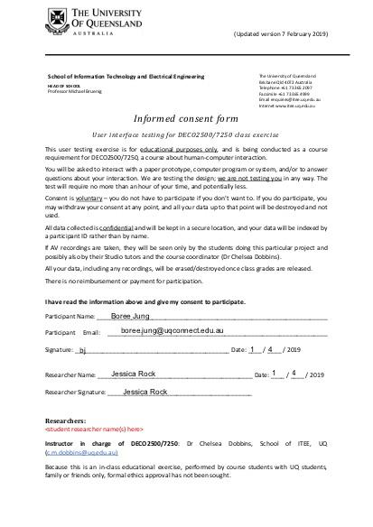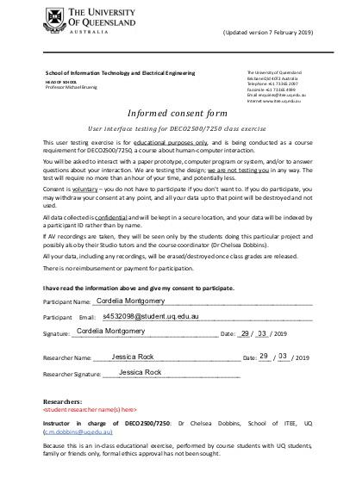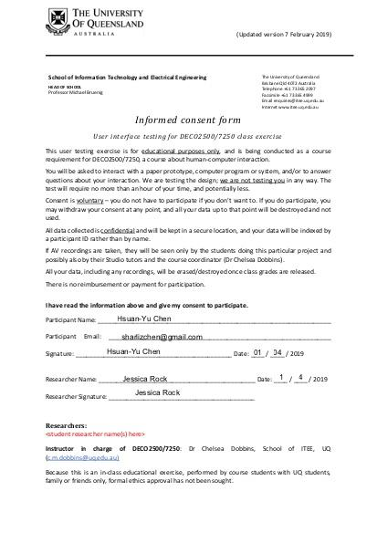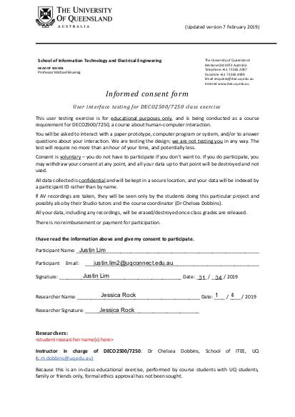

## APPENDIX 7 - HIGH-FIDELITY NOTES

7.1 OBSERVATIONS FOR ALL INTERACTIONS

|  |  |
| --- | --- |
| USER INITIALS: CO | |
| TASK | OBSERVATIONS |
| Login to the application | * Clicked all relevant fields without hesitation |
| Read the tutorial | * Quickly read through the tutorial |
| Create a task | * Able to identify the need for a plus icon * Clicked the ‘task’ icon first, couldn’t find a way to * Still thought task to be intuitive, said there should also be an add on the task page |
| Make Task 1 an important task | * Looked for a brief period * Clicked the star |
| View more details about Task 1 | * Clicked on task straight away * Said it was the same as google calendar (similar to lived experience) |
| Check off/list Task 1 as complete | * Clicked the checkbox straight away * Said that it was intuitive to use the check box |
| Delete Task 1 | * Paused and finally clicked on the ‘x’. * Said it was too small |
| View details of an old task titled ‘Task A’ | * Clicked the ‘previous task’ bar |
| Create a timer | * Clicked timer icon * Clicked plus and went to popup to make a new timer * Made a new timer * Said they thought that the plus only made a task, not a timer |
| Pause timer | * Instantaneously clicked pause * Said it was obvious and intuitively positioned |
| Cancel timer | * Instantaneously cancel * Said it was obvious and intuitively positioned |
| Start a previously saved timer | * Quickly looked about page and clicked ‘previously saved timers’ * Said that they were looking in the same area that previous tasks was |
| Delete saved Timer 1 | * Clicked ‘x’ almost instantaneously * Said that they were looking in the same area that previous tasks was * Said that they were expecting a popup asking to confirm |
| View information on an achievement | * Clicked the trophy icon almost instantaneously * Said they were expecting rewards because of the iconography |
| Return to home page | * Clicked the home icon almost instantaneously |
| View your progress | * Thought that they had already completed the task (asked if what was on the home page was the progress) * Noticed timer was still going and clicked on progress * Said it wasn’t very obvious that it was clickable |
| View your account | * Quickly clicked on account * Said the icon was familiar and expected their account to come up |

## 

|  |  |
| --- | --- |
| USER INITIALS: CC | |
| TASK | OBSERVATIONS |
| Login to the application | * Clicked all relevant fields without hesitation |
| Read the tutorial | * Skipped through tutorial |
| Create a task | * Able to identify the need for a plus icon * Said after clicking the ‘task’ option they would get another popup |
| Make Task 1 an important task | * Clicked on star |
| View more details about Task 1 | * Clicked on task straight away |
| Check off/list Task 1 as complete | * Clicked on task for more info * Clicked on delete * Said that checkbox was not obviously a checkbox |
| Delete Task 1 | * Clicked on delete straight away |
| View details of an old task titled ‘Task A’ | * Clicked on the ‘previous tasks’ arrow |
| Create a timer | * Very quickly went through the same process * Said they liked you could make both through the ‘plus’ icon |
| Pause timer | * Instantaneously clicked pause * Said it was obvious and intuitively positioned |
| Cancel timer | * Instantaneously clicked cancel * Said it was obvious and intuitively positioned |
| Start a previously saved timer | * Clicked on the ‘previous tasks’ bar |
| Delete saved Timer 1 | * Clicked ‘x’ almost instantaneously * Said that they learnt from last time |
| View information on an achievement | * Clicked the trophy icon almost instantaneously * Said they made a connection to the trophy and achievements |
| Return to home page | * Clicked the home icon almost instantaneously |
| View your progress | * Clicked on progress |
| View your account | * Clicked on account |

## 

|  |  |
| --- | --- |
| USER INITIALS: MB | |
| TASK | OBSERVATIONS |
| Login to the application | * Clicked all relevant fields without hesitation |
| Read the tutorial | * Slowly read through the tutorial |
| Create a task | * Clicked on plus * Seamlessly completed the rest of the task |
| Make Task an important task | * Clicked star * Said it was improved from last time |
| View more details about Task | * Clicked task 1 |
| Check off/list Task as complete | * Clicked the checkbox straight away * Said it didn’t really look like a check box |
| Delete Task | * Clicked the ‘x’ |
| View details of an old task | * Clicked ‘previously completed tasks’ bar |
| Create a timer | * Clicked the plus |
| Pause timer | * Instantaneously clicked pause * Said it was obvious and intuitively positioned |
| Cancel timer | * Instantaneously clicked cancel * Said it was obvious and intuitively positioned |
| Start a previously saved timer | * Clicked timer icon * Clicked the ‘previous timer’ arrows * Said it wasn’t obvious and expected the arrow to show a history of timer usage |
| Delete saved Timer | * Clicked the ‘x’ |
| View information on an achievement | * Clicked the trophy icon * Clicked a trophy |
| Return to home page | * Clicked the home icon almost instantaneously |
| View your progress | * Clicked progress, said it was a very effective way of representing progress |
| View your account | * Clicked the account |

## 

|  |  |
| --- | --- |
| USER INITIALS: RM | |
| TASK | OBSERVATIONS |
| Login to the application | * Clicked all relevant fields without hesitation |
| Read the tutorial | * Slowly read through the tutorial |
| Create a task | * Seamlessly completed the task |
| Make Task an important task | * Clicked star |
| View more details about Task | * Clicked task |
| Check off/list Task as complete | * Clicked the task (got more info) * Clicked the checkbox straight away * Said it wasn’t super obvious that it was a checkbox |
| Delete Task | * Clicked the ‘x’ |
| View details of an old task | * Clicked ‘previously completed tasks’ bar |
| Create a timer | * Clicked the plus |
| Pause timer | * Instantaneously clicked pause * Said it was obvious and intuitively positioned |
| Cancel timer | * Instantaneously clicked cancel * Said it was obvious and intuitively positioned |
| Start a previously saved timer | * Clicked previously saved timer (said it was more obvious than last time) |
| Delete saved Timer | * Clicked the ‘x’ |
| View information on an achievement | * Clicked the trophy icon * Clicked a trophy |
| Return to home page | * Clicked the home icon almost instantaneously |
| View your progress | * Clicked progress |
| View your account | * Clicked the account |

## 

|  |  |
| --- | --- |
| USER INITIALS: CaO | |
| TASK | OBSERVATIONS |
| Login to the application | * Clicked all relevant fields without hesitation |
| Read the tutorial | * Slowly read through the tutorial |
| Create a task | * Seamlessly completed the task |
| Make Task an important task | * Clicked star |
| View more details about Task | * Clicked task |
| Check off/list Task as complete | * Clicked the task |
| Delete Task | * Clicked the ‘x’ |
| View details of an old task | * Clicked ‘previously completed tasks’ bar |
| Create a timer | * Clicked the plus |
| Pause timer | * Instantaneously clicked pause * Said it was obvious and intuitively positioned |
| Cancel timer | * Instantaneously clicked cancel * Said it was obvious and intuitively positioned |
| Start a previously saved timer | * Clicked previously saved timer (said it was more obvious than last time) |
| Delete saved Timer | * Clicked the ‘x’ |
| View information on an achievement | * Clicked the trophy icon * Clicked a trophy |
| Return to home page | * Clicked the home icon almost instantaneously |
| View your progress | * Clicked progress |
| View your account | * Clicked the account |

## 

|  |  |
| --- | --- |
| USER INITIALS: CB | |
| TASK | OBSERVATIONS |
| Login to the application | * Clicked all relevant fields without hesitation |
| Read the tutorial | * Slowly read through the tutorial |
| Create a task | * Seamlessly completed the task |
| Make Task an important task | * Clicked star |
| View more details about Task | * Clicked task |
| Check off/list Task as complete | * Clicked the task (got more info) * Clicked the checkbox straight away * Said it wasn’t super obvious that it was a checkbox |
| Delete Task | * Clicked the ‘x’ |
| View details of an old task | * Clicked ‘previously completed tasks’ bar |
| Create a timer | * Clicked the plus |
| Pause timer | * Instantaneously clicked pause * Said it was obvious and intuitively positioned |
| Cancel timer | * Instantaneously clicked cancel * Said it was obvious and intuitively positioned |
| Start a previously saved timer | * Clicked previously saved timer (said it was more obvious than last time) |
| Delete saved Timer | * Clicked the ‘x’ |
| View information on an achievement | * Clicked the trophy icon * Clicked a trophy |
| Return to home page | * Clicked the home icon almost instantaneously |
| View your progress | * Clicked progress |
| View your account | * Clicked the account |

## 

## 